**ANGULAR NOTES**

* What is Angular?
  + Angular is a open-source frontend development platform developed by google.
* Why Angular?
  + It is used to build web and mobile interactive dynemic web applications.
* Frontend: Browser(Chrome,Firefox, IE, Edge etc.)
  + Html, CSS,Bootstrap, Javascript, JQuery,Angular JS, Angular etc.
* Static: A page which can't changes it's content based on the request.
  + To build static page we use static technologies like HTML, CSS, SASS,LESS, Bootstrap etc.
* Dynemic: A page which can changes it's contetn based on user's request.
  + To build dynemic pages Javascript, jQuery, Angular JS, Angular, React JS, Vue JS etc.

**Prerequisites:**

* HTML, CSS and Javascript(3 or 4 Hrs)
* Javascript
* Type Script
* Angular App Developement
* Node JS
* Angular CLI
* Unit Testing (Karma, Jasmin and Protractor)

**Note:**

* To learn about Angular2+ it's optional to have the knowledge on Angular JS.
* Angular2+ is a complete re-write of Angular JS 1.x.
* Librabry: It is a set of functionalities, Once if it is developed it is very easy to use.Examples: jQuery, Angular JS etc.
* Framework: It is a collection of librabries and also an environment to build application. Examples: Angular, .Net
* If it is an Angular JS we can directly include into the HTML by using <script> tag.
* Angular is a framework , so that to build application by using it we need to have environment.

**Software Requirements to build Angular Applications:**

- In order to build Angular2+ or any Higher versions of angular in your machine we need to have following things.

* 1. IDE/Code Editor
  2. Node JS
  3. NPM(Node.js Package Manager)
  4. TypeScript
  5. Angular CLI(Command Line Interface)

1. **IDE(Integrated Dev Environment)/Code Editor:**
   * Code Editor is used to write the code and to compile/run the application will depend on some other tools.
   * Examples: Notepad, Notepad++,Sublime,Atom,WebStrom etc.
   * IDE is integrated everything like Write code Compile Code and also Execute the Code.
   * Examples: Visual Studio Code
   * Here to build Angular applications mostly we using "Visual Studio Code".

Advatages of Visual Studio Code:

* + It is Open source code editor, provided by Microsoft.
  + It is light weight.
  + It supports major programming languages Java, C#.Net, C, C++, Typescript, HTML, Javascript etc.
  + It having built in support for "GitHub".
  + It support intellisence feature.
  + It support debugging.
  + It support extensions which can be used to build applications.

**2. Installing Node.js and NPM:**

* + Node.js is a server which will takecare the execution of Angular Applications.
  + If we want to work with Angular9, minimum Node.js version shoud be greater than 4.6
  + NPM stands for "Node Package Manager", It is a repository which contains all the packages for client side application development.
  + Once we install Node.js then NPM will be automatically installed.
  + To check the versions that are installed in our OS we use the following commands like
  + Node.js - node -v
  + NPM - npm -v

**3. Typescript:**

* + It is a superset of Javascript.
  + Typescript = Javascript + Datatypes.
  + It comes with proper syntax which can be used to define the JS members.
  + To Install the typescript we use follwoing command like
* npm install -g typescript@[version]
  + To verify the version of typescript we use command like
* tsc -v

**4. Angular CLI:**

- CLI means Command Line Interface used to write the commands.

- Angualr CLI is used to create, build and run the angular applications by writing commands.

- To verify the version we use

> ng version

- To install the Angular CLI we use command like

> npm install -g @angular/cli

**Create First Angular Application:**

- To create Angular application we have to follow below steps

* Note: To create an angular appliction by using Angular CLI, we must have npm and Angular CLI installed in the machine.

**Step**-1: Open the Command Prompt with adminstrator permissions.

**Step**-2: Specify the location where we want to create Angular application.

> D:

> cd D:\AngularExamples(Jun)

OR else you can do one more thing.

* Go to the path where you want to create application

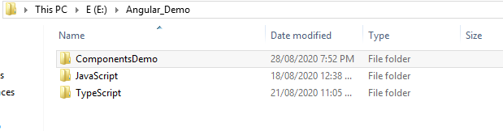

* type cmd in the url.

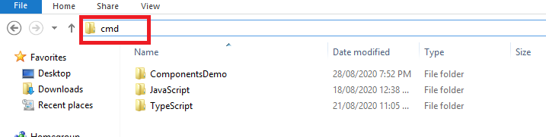

* It will automatically open command prompt.

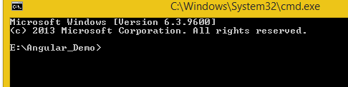

**Step**-3: To create an Angular application we use command like

> ng new <applicationName>

For Ex: **ng new ComponentsDemo**

**Note**:

* + Once if we enter will get two questions
  + About Routing > Y
  + Stylesheet > CSS
  + Once if the application is ready we have to chnage the directory.

**Step** 4 :- We can open our application using command prompt.

Need to type :- code .

It will open your application in vs code.

That will be look like followings.

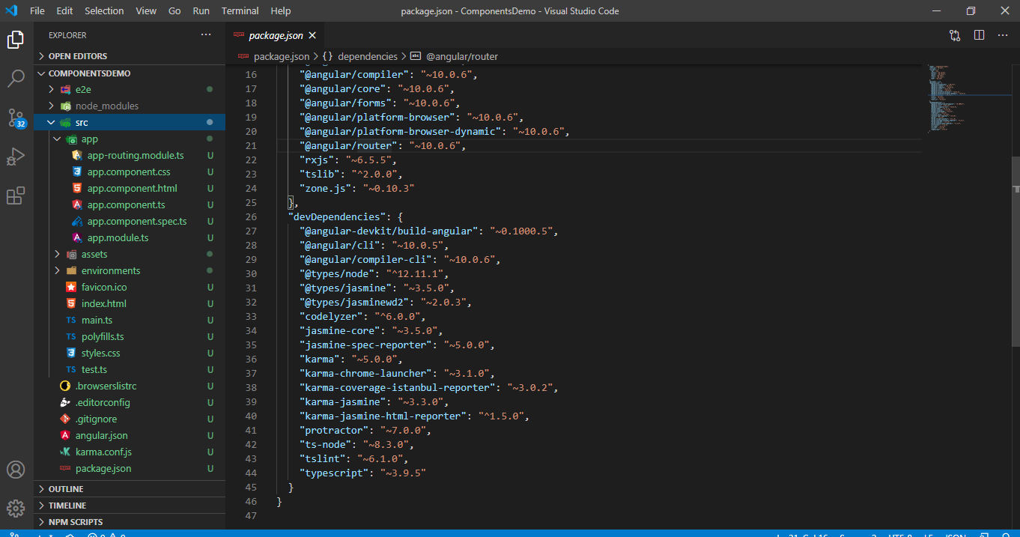

**Step**-5: Execute the application

* ng serve/ng serve –open

Or

* Ng s -o

Once we execute the above command it will open the application in browser with port number i.e. 4200.

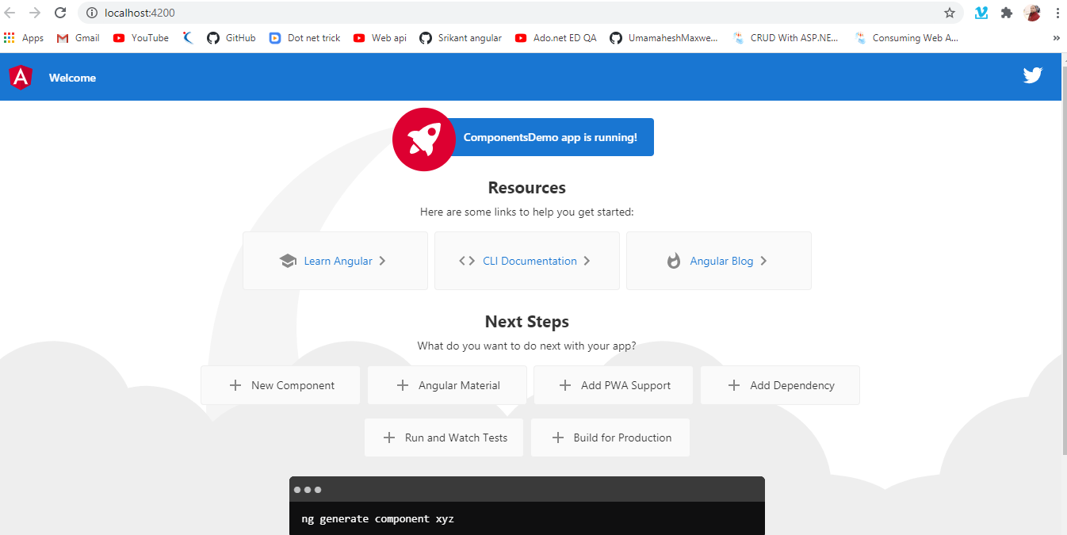

**Folder Structure of an Angular9 application:**

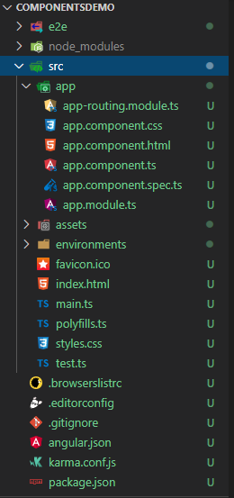

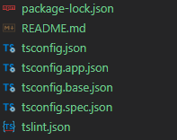

1. **e2e folder:**

It stands for End to End Testcases. It is not testing functionality, rather it will test the application/monitor at production server. It monitors everything that who logged in into the application, how much time spent in the app, how many pages visits and when loged out that information is tracked by e2e folder.

Dev Environement => QA/Testing Env => Production Env

Unit Testing => Bugs => e2e folder

1. **node_modules:**

This folder contains collection of packages that are used to run the angular applications, these packages wil get installed automatically when we created a first angular application. Later if we install thrid party packages like bootstrap, jquery, poper.js etc. if we install will be there in the node_modules folder.

1. **src:**

Source folder for the application, This folder can be used to write the source code by the developer and it can contains components, services, modules, routings etc.

1. **app Folder:**

This is the application folder. Whenever you want to create any component, service or module, you need to create within this app folder. Please have a look at the following image which shows the files which are by default created within the app folder when you create an angular application. As you can see, by default it creates one component (app.component.ts) and one module (app.module.ts) and an angular application should have at least one component and one module.

1. **assets Folder:**

This is the folder where you can store the static assets like images, icons, etc. which needed to be copied extensively while building your application. Please have a look at the default assets folder which angular framework creates for us.

1. **environments Folder:**

This folder is basically used to set up different environments. Here, you can find two files as shown in the below image.

environments Folder in angular:

You can use this file to store environment (either production or development environment) specific configuration such as the database credentials or server IP addresses. These two files are as follows:

- environment.prod.ts. This file for the production environment.

- environment.ts. This file for the development environment.

1. **favicon.ico:**

It is the icon file that displays on the browser tab.

1. **index.html:**

This HTML file contains HTML code with the head and body section. It is the starting point of your application or you can say that this is where our angular app bootstraps. If you open it you will find that there are no references to any stylesheet (CSS) nor JS files this is because all dependencies are injected during the build process.

1. **main.ts file:**

This is the entry point for our angular application. If you ever worked with programming languages like Java or C or C#, then you can compare this with the main() method of such application.

1. **polyfills.ts:**

This file is basically used for browser-related configuration. In angular, you write the code using typescript language. The Polyfills.ts file is used by the compiler to compile your Typescript code to a specific JavaScript method so that it can be parsed by different browsers.

The polyfill.ts file imported the required script which is required for running an Angular application. This is because the angular framework uses the latest features of JavaScript which are not available in the current version of JavaScript supported by most of the browsers. So, basically, the polyfills.ts file fills the gap to provide the features of JavaScript that are needed by Angular and the feature supported by the latest browsers. It is mainly used for backward compatibility

1. **.editorconfig file:**

This file is basically used to set up the team environment. In real-time, many developers may work on a single project. And each developer may follow different coding standards to declare variables, classes, style, size of each character, length, etc. But in the end, we need to merge the code of each developer to produce the final product. At that time, it may produce some error or messy code as each developer having different coding standards. In order to solve this problem, the editorconfig file is used where the standard rules are defined which needs to be followed by the developers in teamwork. And moreover, the developers do not have access to this file and only the manager or the team lead who defines the rules can only have access to this file.

1. **gitignore file:**

The files which you want to ignore in the git repository, you need to put within this gitignore file.

1. **angular.json file:**

From angular 6, the angular-cli.json file has been replaced by angular.json. That means if you are working with angular 5 or any lower, then you will not find this file instead you will find the angular-cli.json file.

This is one of the most important files and it contains all the configuration of your Angular Project. It contains the configurations such as what is the project name, what is the root directory as source folder (src) name which contains all the components, services, directives, pipes, what is the starting point of your angular application (index.html file), What is the starting point of typescript file (main.ts), etc. We will discuss this file in detail in our upcoming article.

1. **browserslist:**

This file is currently used by autoprefixer to adjust CSS to support the specified browsers.

1. **test.ts and karma.config.js**

These two files are basically used for testing purposes.

The test.ts file is the configuration file of Karma which is used for setting the test environment. Within this file, the tester will write the unit test cases for testing the project.

The karma.config.js file is used to store the setting of karma i.e. test cases. It has a configuration for writing unit tests. Karma is the test runner and it uses jasmine as a framework. Both tester and framework are developed by the angular team for writing unit tests.

1. **package-lock.json:**

The package-lock.json is automatically generated for those operations where npm modifies either the node_modules tree or package.json. In other words, the package.lock.json is generated after an npm install. We will discuss this file in detail in our upcoming articles.

1. **package.json:**

This file is mandatory for every npm project. It contains basic information regarding the project (name, description, license, etc), commands which can be used, dependencies – these are packages required by the application to work correctly, and dependencies – again the list of packages which are required for application however only during the development phase i.e. we need Angular CLI only during development to build a final package however for production we don’t use it anymore. We will discuss this file in detail in our upcoming articles.

1. **README.md file:**

README is the file that contains the description or description of the project which we would like to give to the end-users so that they can start using our application in a great manner. This file contains the basic documentation for your project, also contains some pre-filled CLI command information.

1. **tsconfig.app.json:**

This file is used during the compilation of your application and it contains the configuration information about how your application should be compiled.

1. **tsconfig.json:**

This file contains the configurations for typescripts. If there is a tsconfig file in a directory, that means that directory is a root directory of a typescript project, moreover, it is also used to define different typescript compilation related options.

1. **tsconfig.spec.json:**

This file is used for testing purposes in the node.js environment. It also helps in maintaining the details for testing.

1. **tslint.json:**

This is a tool useful for static analysis that checks our TypeScript code for readability, maintainability, and functionality errors.

**Building blocks of Angular Applications:**

Angular is made of following things like

1. **Component**: It is used to maintain the state/data of the application, and also components can be used to write the businuss logic.
2. **Meta Data/Decorator**: This will contain information about the components, services, pipe, directives etc.
3. **Template/Html**: It contains HTML logic(Presentation Logic).
4. **Data Binding**:It is communication between component and HTML to share the data.
5. **Modules**:It is used to improve the modularity for an application, It contain group of components, directives, services etc., based on the module level.
6. **Services**: It is resuable code that can shared across multiple components.
7. **Depedency** **Injuction**: Injecting(Loading) service object into components.
8. **Directives**: It is used to manipulate the DOM
9. **Pipes**: It is used to transform the values.
10. **Routing**: It is used to provide the navigation facility for the angular application.Angular is having a feature i.e Single Page Application, where the complete application content will be loaded into single page, inorder to implement that we can have routing.

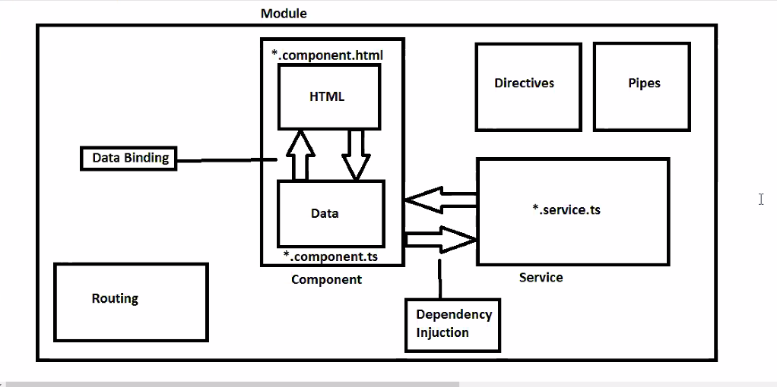

**Notes**:-

* Once we share the project, first will install the node modules into the project folder by using a command i.e. "npm install" and then will run the application.
* npm will take the package information from a file i.e. "package.json" and the required packages to run the angular application.

Angular Application Execution:

-> Once we run the angular application by using a command "ng serve" then it will excute the application in following sequence.

=> Main.ts => AppModule => AppComponent => Include the selector in index.html file

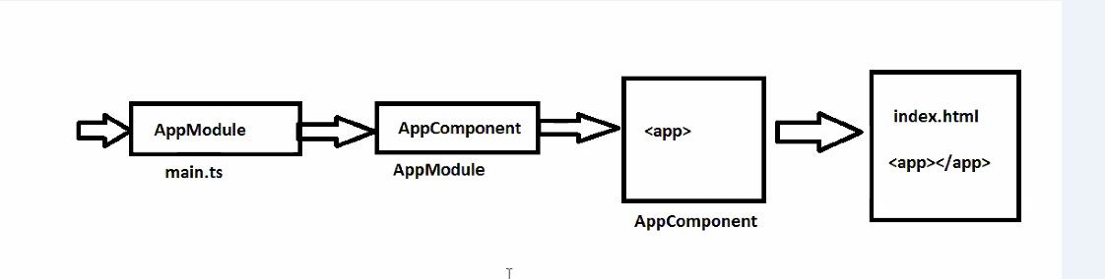

**Packages in Angular:**

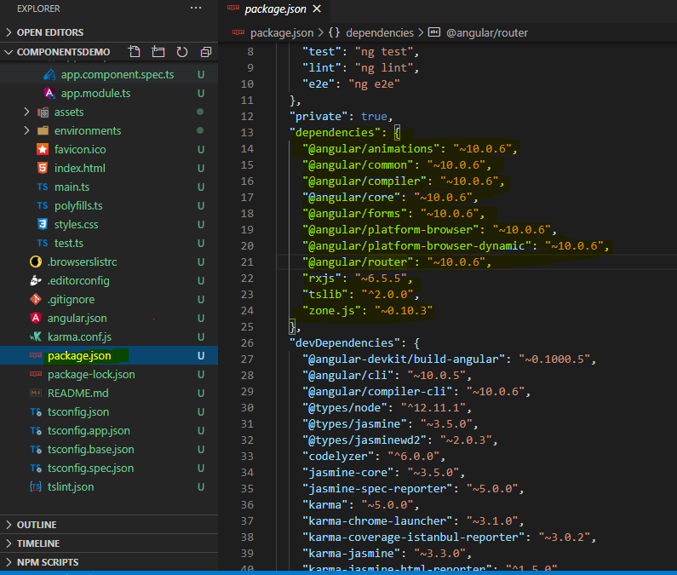

* Angular is completly developed based on packages.
* And to each feature of an angular application we must have to install all the packages based on the requireemnt.

- We can download these packages from "npm" librabry.

**@angular/core:**

- This package provide the classes and interfaces that are used to run the angualr application. It is mandatory package to run the angular application.

- It contains decorators like @Component, @NgModule,@Input, @Output @Inject etc. and also it comes with component life cycle hooks.

**@angular/compiler:**

- This package is used to convert template code into javascript code, In angular compiler is background thread which is not required to invoke explicitly.

- This package was wrapped with a package "@angular/platform-browser-dynemic" and "@angular/platform-browser".

**@angular/platform-browser-dynemic:**

- It will takecare of compilation process of an angualr and also verify the browser compatability and throw exception in console.

**@angular/common:**

- This package contains pre-defined direcctives and pipes that are required to add the additional behviour to the template.

- It contains directives like *ngIf, *ngFor, *ngSwitch etc.

- It comes with pre-defined pipes like uppercase,lowercase,currency etc. and also it comes with a module "Common Module".

**@angular/forms:**

- To work with data entry forms we have to include this package.

- This package contains ReactiveForms, Normal forms and validations

**@angular/router:**

- This is include the page navigation for an application, it have a module i.e. Routing Module

**@angular/http:**

- This is used to send Http based ajax request to the servers, This package will works based on a library i.e. Rxjs(Reactive extension for Javascript).

- It comes with a module i.e. "HttpClientModule".

**@angular/meterial:**

- Dynemic UI creation.

**Note**: The above all packages are available as the part of core library reference, but sometimes we may have to install third party libraries like

- Typescript

- System.js

- Rxjs

- Zone.js

- Jasmine,Protractor, Karma

- tslint

**Components in Angular:**

* In Angular a component is a typescript class, whcih can be used to define the members and also used to present the data to the user.
* Angular is complelty a component based architecture, which means we can have atleast one component in order to run the application.
* The defualt component is "app.component.ts", apart from that we can have any number of components in the application.
* To invoke the component we use a tag "selector" by using this we can invoke the components in any where.
* Every component in angular is having a decorator i.e. "@Component()"

Syntax:

* import {Component} from "@angular/core";
* @Component({metadata})
* export class RegisterComponent{

variables,

methods

}

Note: To create a component by using angular cli we use a command like

> "ng generate component <nameOfComponent>"

> "ng g c <nameOfComponent>"

- Once we execute above command it will generate follwoing files like

* - app.component.ts : Businuss Logic
* - app.component.html : Presentation Logic
* - app.component.css : Style Sheet
* - app.component.spec.ts : Unit Testing Code.

Metadata properties of angular @Component() decorator:

1. **selector**: Used to represent a tag name which is used to invoke the component
2. **template**: Used to write the HTML logic inside the component class.
3. **templateUrl**: Represents the html file that has to be rendered when the component invoked
4. **styleUrls**: It is a list of style sheets that can be given for an HTML pages
5. **providers**: Used to inject the services into the components.
6. **animations**: Represents the animations that to be performed in the component level.

Example : - We are creating 1 component.

* Ng g c First

It will add following files

1. first.component.ts : Businuss Logic

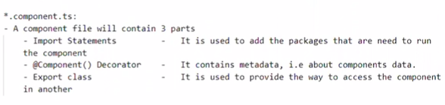

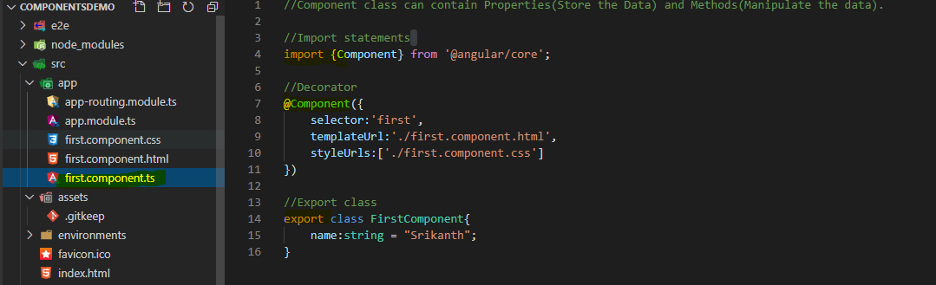

1. first.component.css : Style Sheet

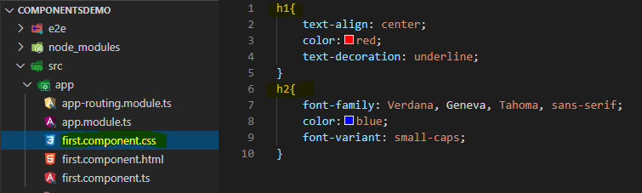

1. first.component.html: : Presentation Logic

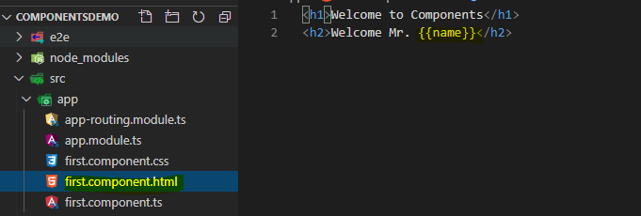

1. first.component.spec.ts

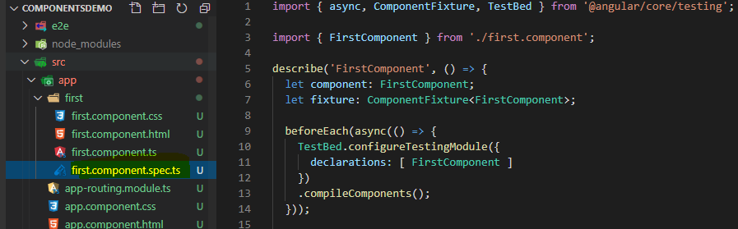

After this need to configure in app.module.ts file.

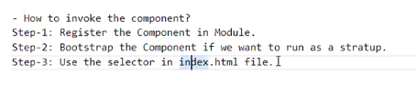

1. app.module.ts:

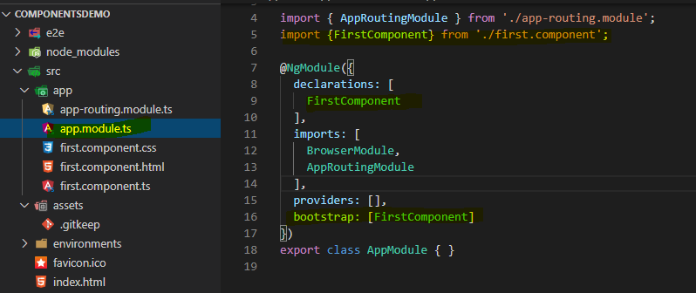

1. Declare selector in index.html-

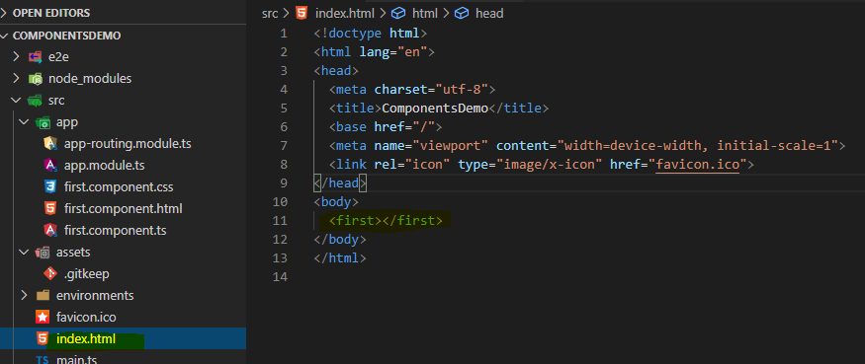

To run output : > ng s -o

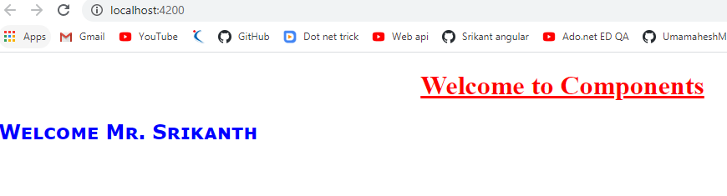

**Display Nested Components**

First you can create component with the name **second** using following command.

* Ng g c second

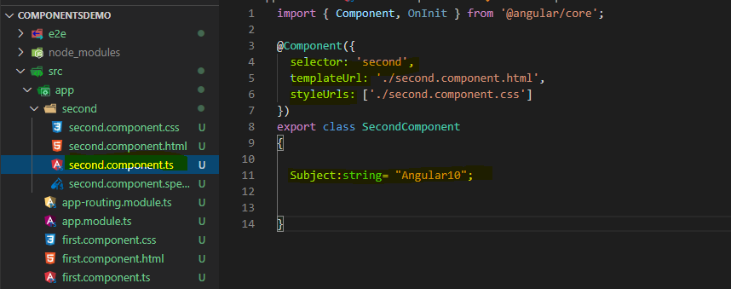

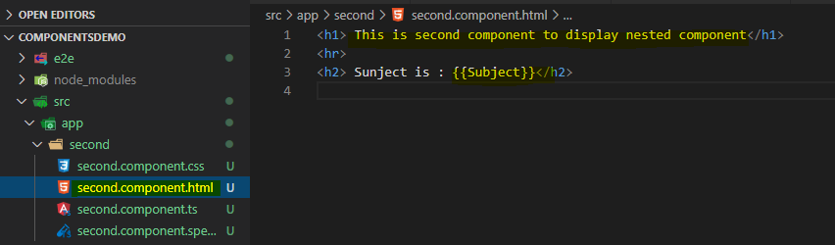

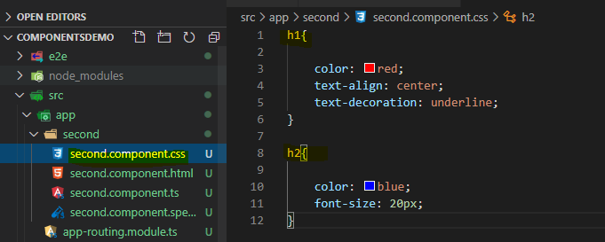

* To call in nested component just define second component selector name in fir.component.html file.

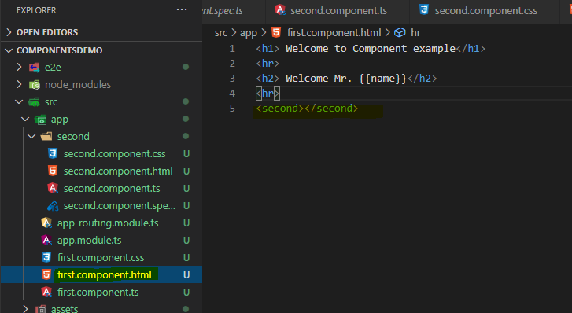

Run - > ng s –o

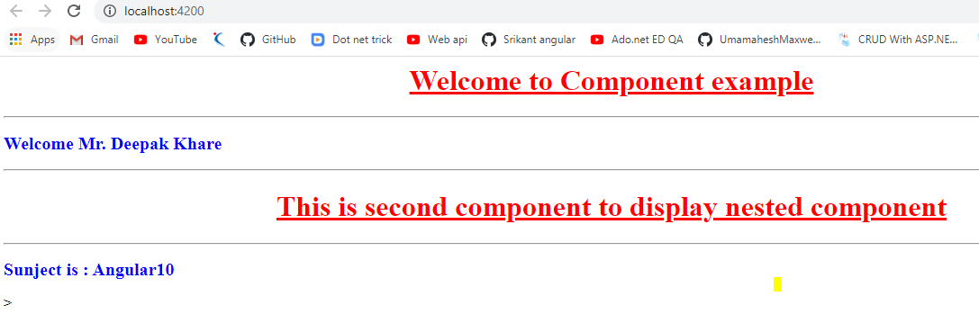

**Module in Angular**

What is Module and how to use?

* Module is used to improve the modularity for the angular application.
* In Angular a module is a collection of Components, Pipes, Directives, Modules Services etc.
* Everything once we create that has to be registered under the Module.
* By the default angular application is having one Module i.e. "app.module.ts"
* It is a typescript class file, if we want to convert it into a module we use a decorator i.e. "@NgModule()".

**Metadata Properties of a Module**:

1. **declarations**: It is an array of elements, which can be used to keep all the components, pipes that are related to that module.
2. **imports**: Represents the list of modules that we want to import into the current module.

Note: In this section we can include pre-defined modules like FormsModule, RectiveFormsModule,BrowserAnimationsModule, HttpClinetModule, RouterModule etc,

1. **exports**: Represnets the list of components and pipes that we want to share it to another modules.
2. **Providers**: This is used to register the services, Once if we registered then we can use it in all the components that are part of the module.
3. **bootstrap**:Used to specify which component has to be displayed on the browser, when intial load of application.

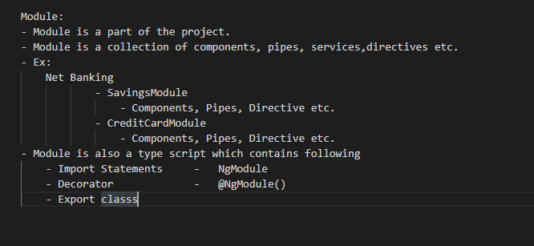

**Example** : Lets create 1 module with the name [**Home.module.ts**](http://Home.module.ts)

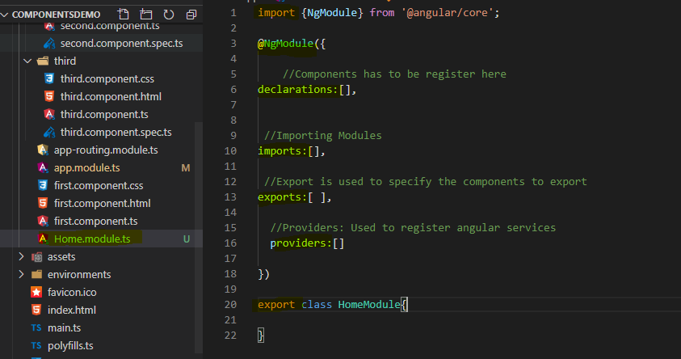

Suppose we want to call second.component.ts from [Home.module.ts](http://Home.module.ts) then write following code.

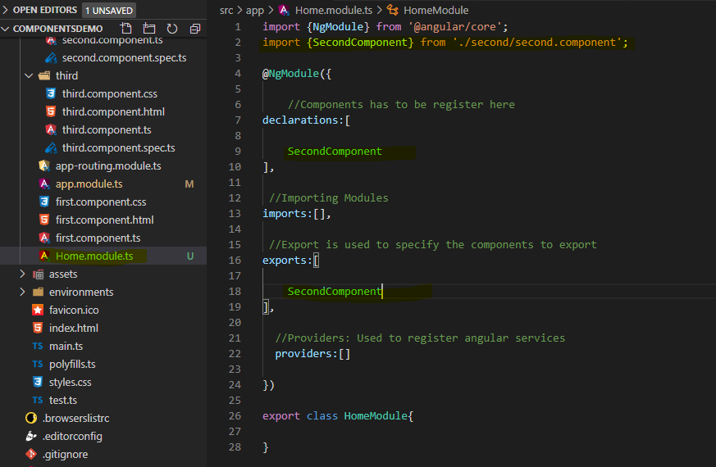

**After that register** [**Home.module.ts**](http://Home.module.ts) **in app.module.ts file**

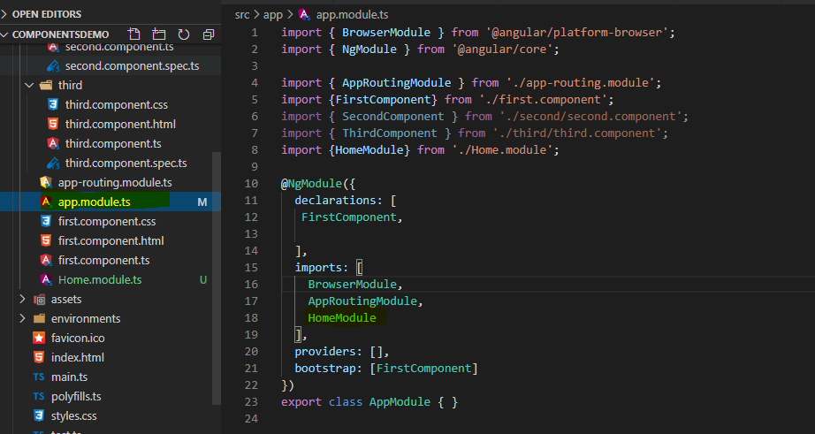

Output : -

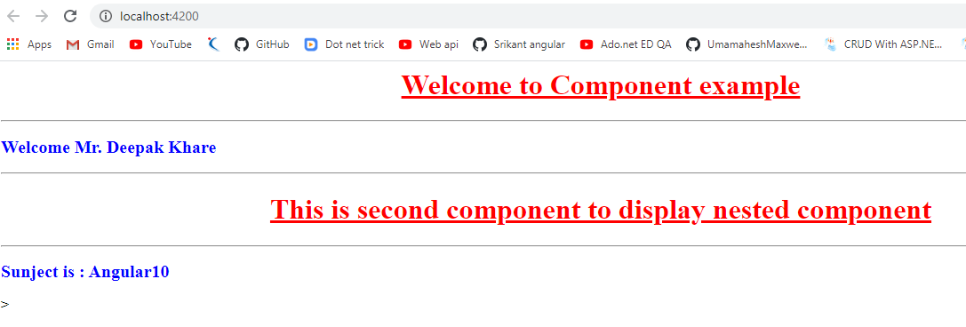

**Data Binding in Angular:**

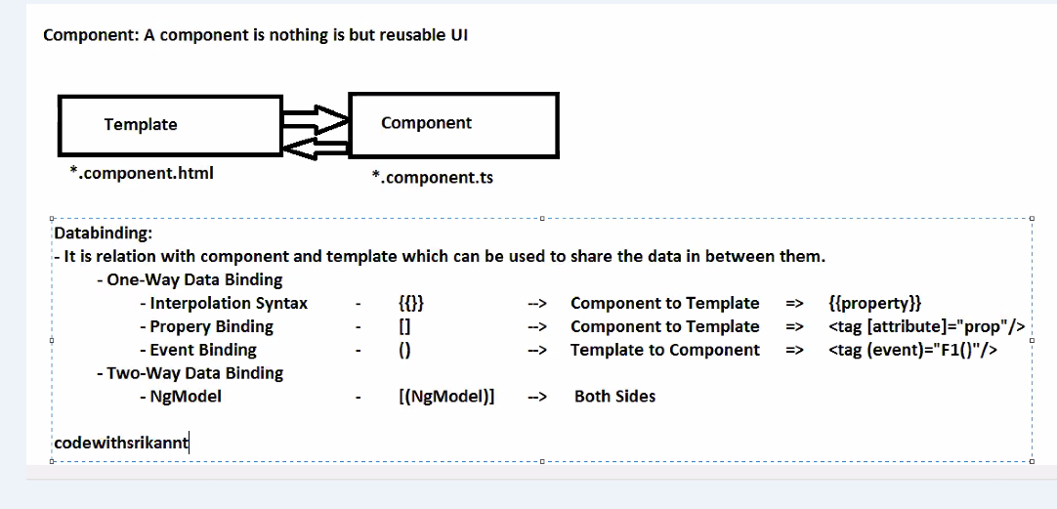

* Sharing the data from component to the template and viceversa.
* It is a relation between the template and component that, once if we do any modifications on component that will be modify the template and anything if we are modifying from template that value will chnage in component.

- We have two types of data binding:

**1. One way DataBinding: -**

1. **Interpolation Syntax**: **{{property}}**

- It displays the value of the property in the template.

- When the property changes it's value then same value will be updated on the template.

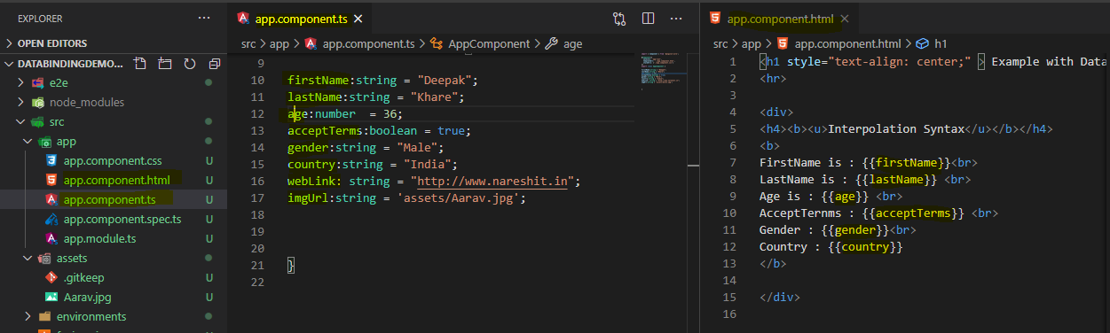

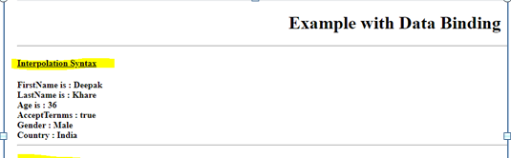

1. **Property Binding**: **<tag [attribute] = "property"></tag>**

- "Property Binding" is used to send the data from component to template and assign the same into an attribute of the tag.

- When the property is changes it's value same value will be updated to the tag's attribute as well.

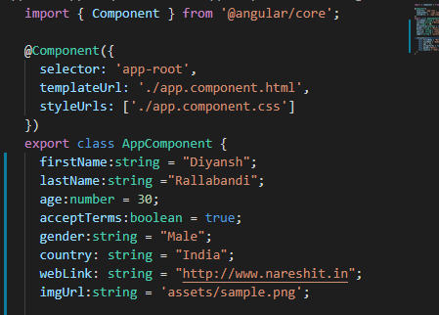

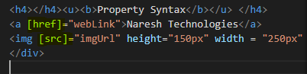

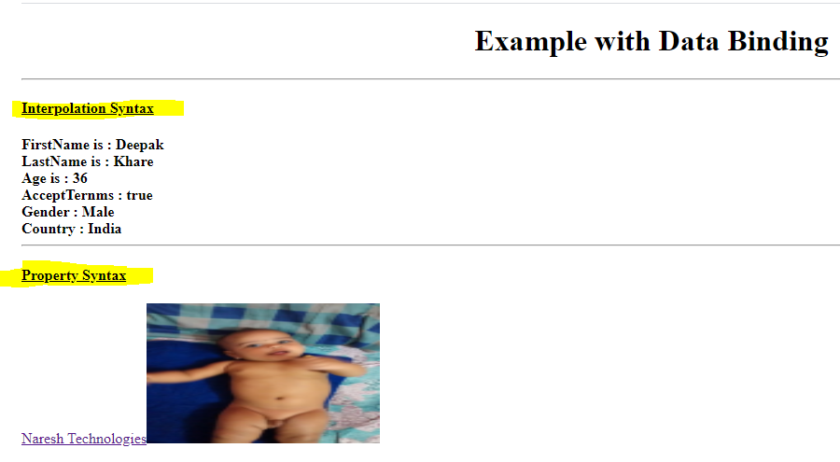

1. **Event Binding**: **<tag (event)="method()"></tag>**

- It is used to pass an event/notifications from template to component.

- Here events will not start with "on" keyword.

Example: - We have written 1 function with the name **changeData(). And will call this in click event and any other event, its your wish.**

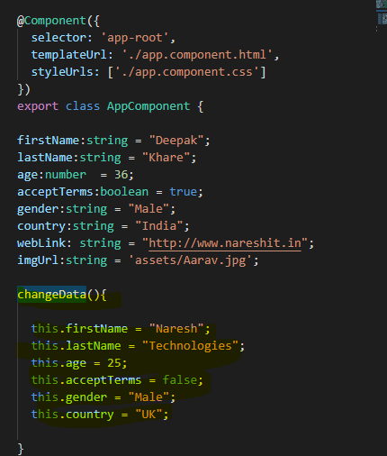

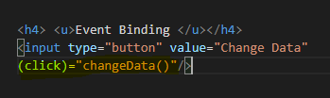

O/p: - Before clicking on button.

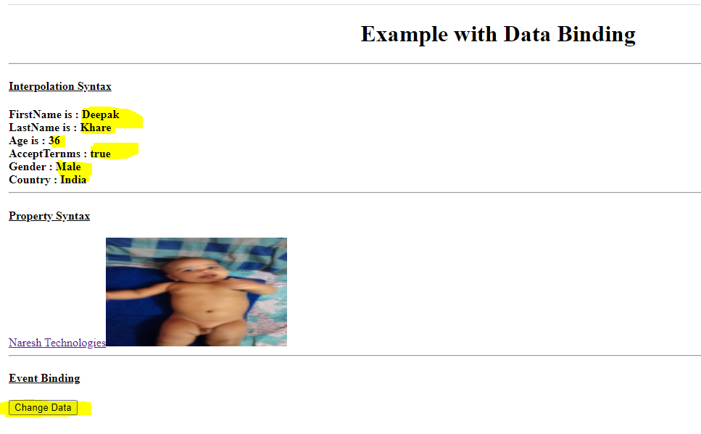

**After clicking on button data will be change in interpolation syntax area.**

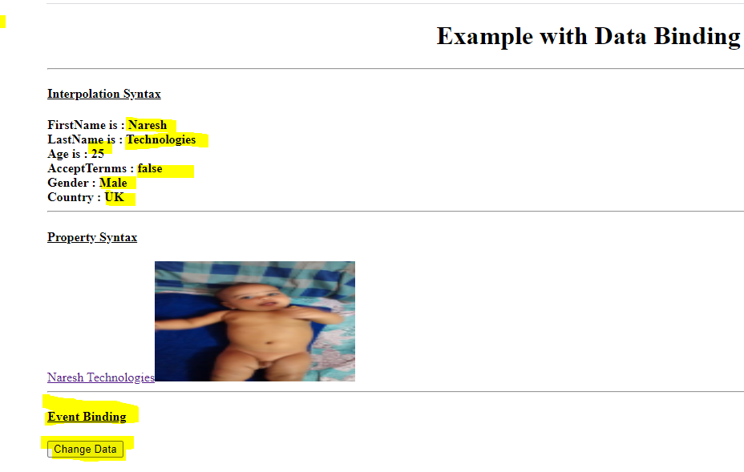

1. **Two Way Binding:**

**<tag [(ngModel)] = "property"></tag>**

* + It is the combination of property binding and also event binding.
  + When we made changes in template will get effected in component and if automatically for template changes in component also.
  + To implement this we use [(NgModel)] directive.

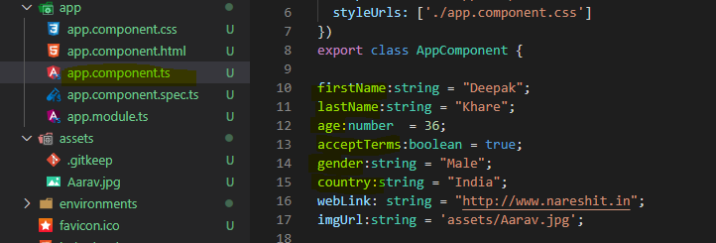

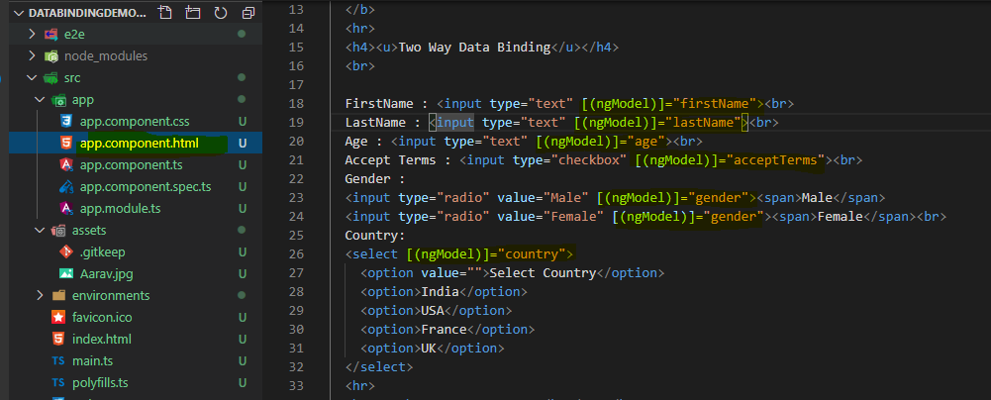

Then execute this you will get following error.

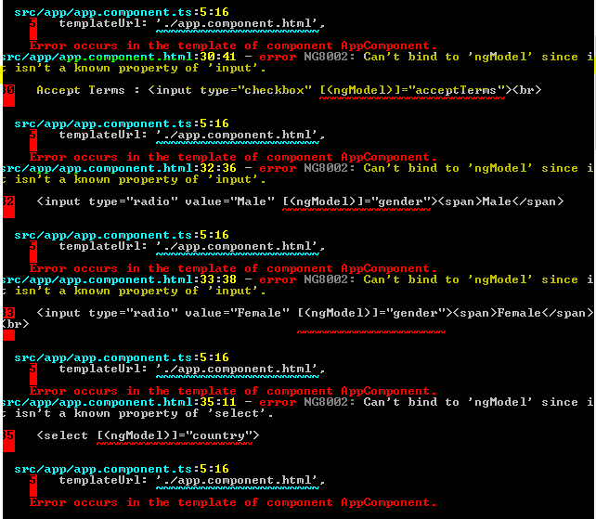

To remove this error you have to include module i.e. FormsModule under the app.module.ts

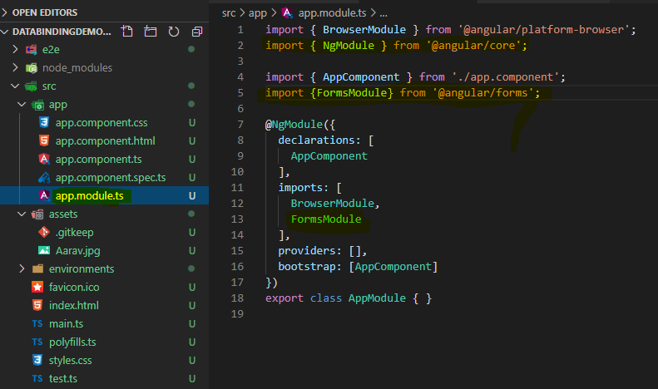

Note:

* Two way data binding is applicable only for <input> and <select> tags.
* If we want to use input elements/Forms in angular appliction we should include a module i.e. "FormsModule" under the module.ts file.

Output:-

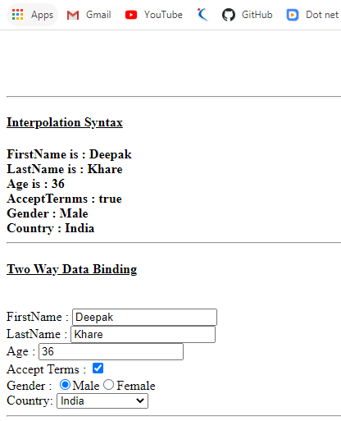

If you change text box value it will reflect in above text area in interpolation syntax and vise versa.

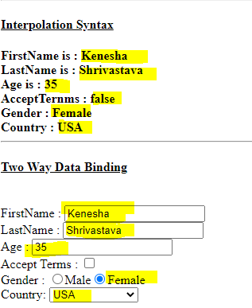

Assignment:1.

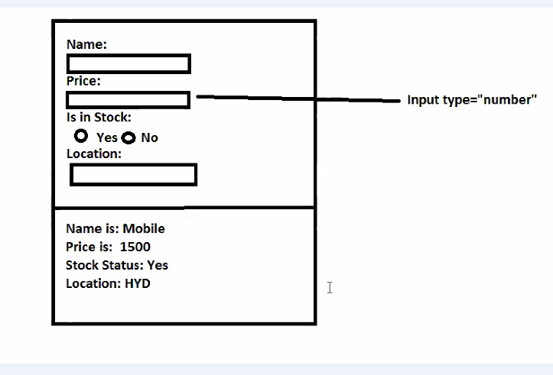

Do the data binding and display content

Notes: to upgrade your angular version need to follow following command.

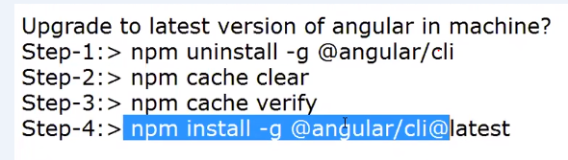

Notes: - To add bootstrap integration need to follow following commands: -

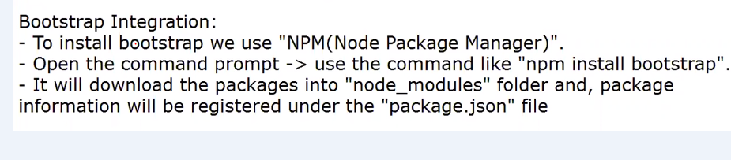

**To apply bootstrap you have to configure in style.css file**

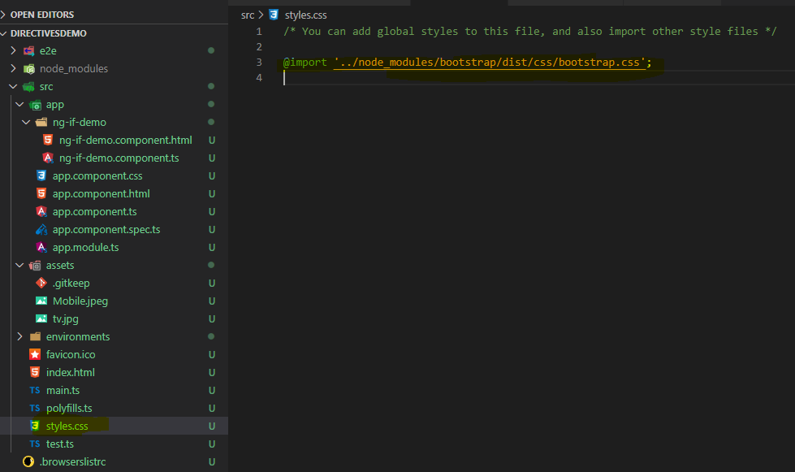

-------------------------------------------------------------------------------------------------------------

**Builtin - Directives in Angular:**

**Directives: A directive is used to add the additional behaviour to the DOM elements.**

1. **Structural** : will start with "*", we have like *ngIf, *ngFor, *ngIf and else,*ngSwitch etc. which can be used to manipulate the DOM. That means it can be render HTML elements based on the condition.

It just used to add the structure for the DOM, It just used to add the elements into the DOM at runtime based on conditions. Examples: *ngFor, *ngIf, *ngSwitch,*ngIf and else, *ngSwitchCase etc.

1. **Attributes** : It will be used to change the behaviour of the DOM.

These directives will add/modify the behaviour of the elements like adding colours dynemically or removing colors and all the CSS properties if we want to add then will use this. Example [NgStyle] and [NgClass]

1. **Component** : Every component's HTML file is a component directive.
2. **Structural Directive : -**
3. \***ngIf** : It is used to render the HTML element based on condition, if the condition is true then will get display the element else will not added to the DOM.

- It is a structural directive which can be used to manipluate the DOM elements means dynemically we can add/remove the elements based on the conditions.

**Syntax** - <tag *ngIf="property"></tag>

- Once if the property value is true then it will display that element, else it won't display.

Example:- Let create component

* Ng g c ng-if-demo --skipTests –is

Note: - 1. skipTests isused to ignore spec.tc file. That means using this command spec.ts file will not generate.1

1. –is : - is used to ignore css file

After executing this command only 2 file will be generate.

1. Ng-if-demo.component.ts
2. Ng-if-demo.component.html

Whenever you will create component you have to configure in app.modue.ts file

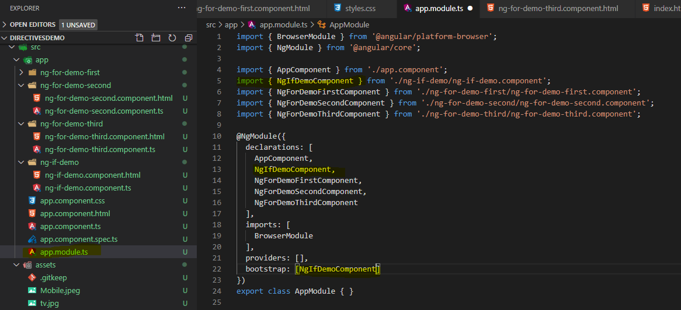

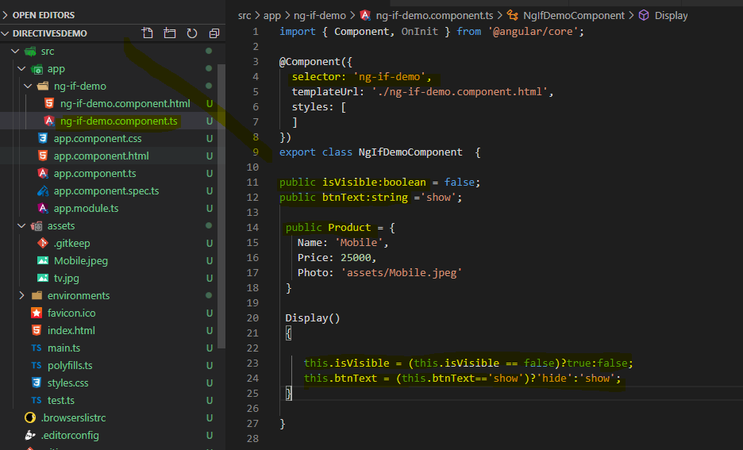

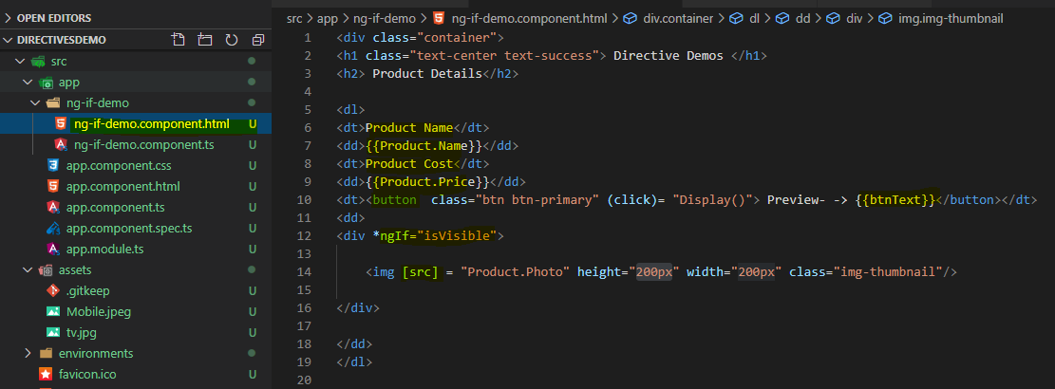

Then provide selector in index.html

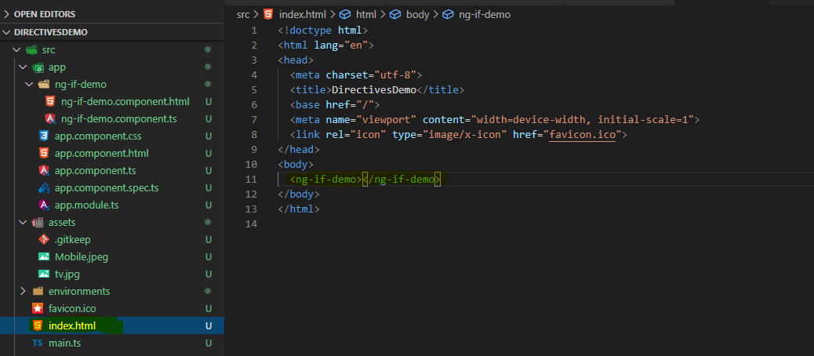

Output: - When click on show button.

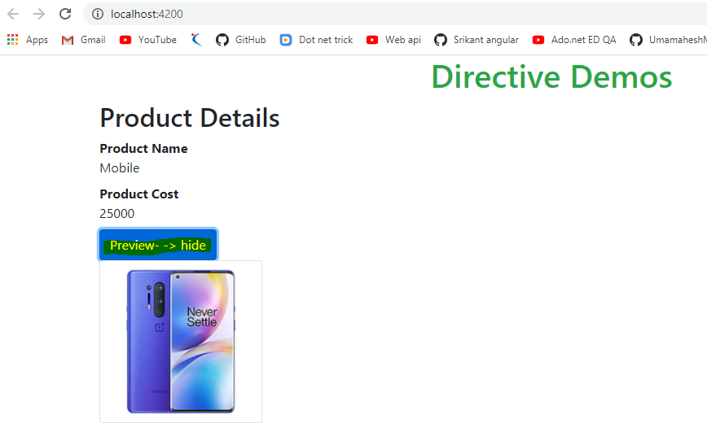

When click on hide.

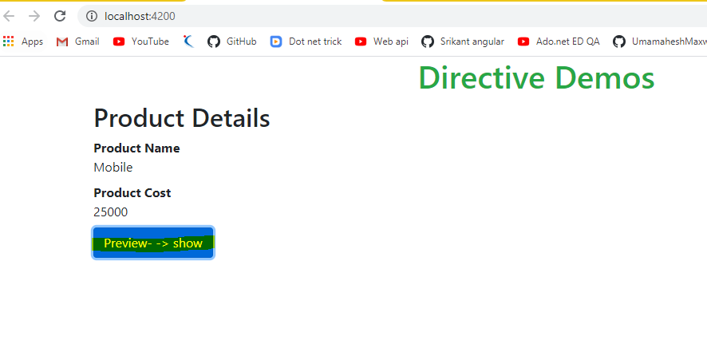

1. **\*ngFor**: It is used to proces the collection and generate the HTML tags dynemically.

* It is a directive which can be used to process the collection members like Array, JSON, Objects etc.
* For every iteration it will generate an element and that element is processed.

**Syntax**: - <div *ngFor="let item in collection"> {{item}} </div>

<tag *ngFor="let x of Collection">...</tag>

Example 1- ng g c ng-ForDemo-First –skipTests -is

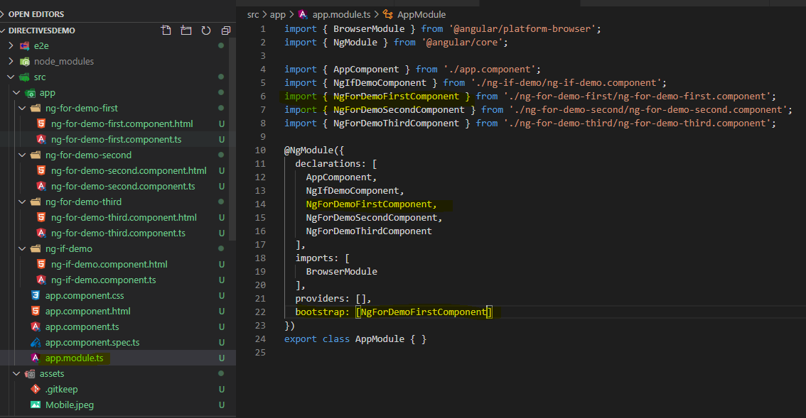

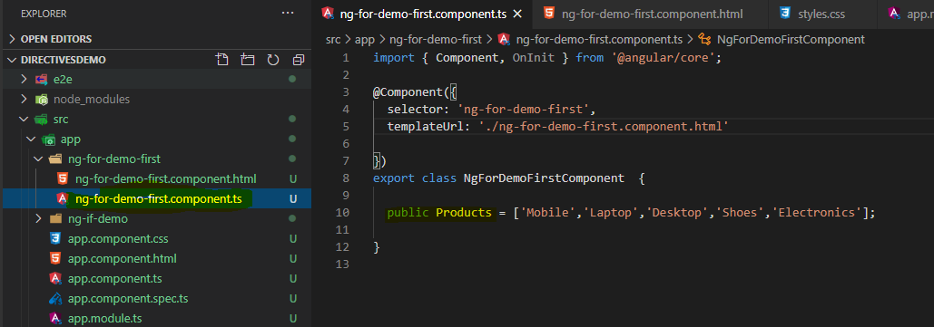

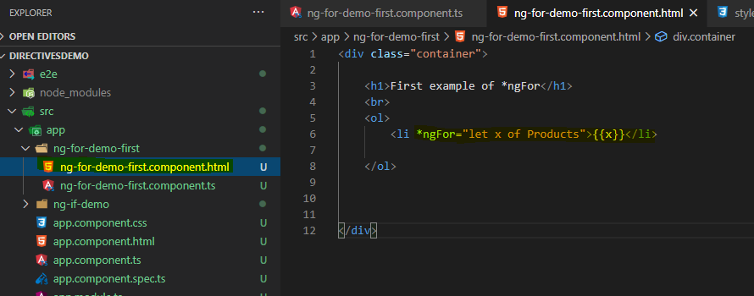

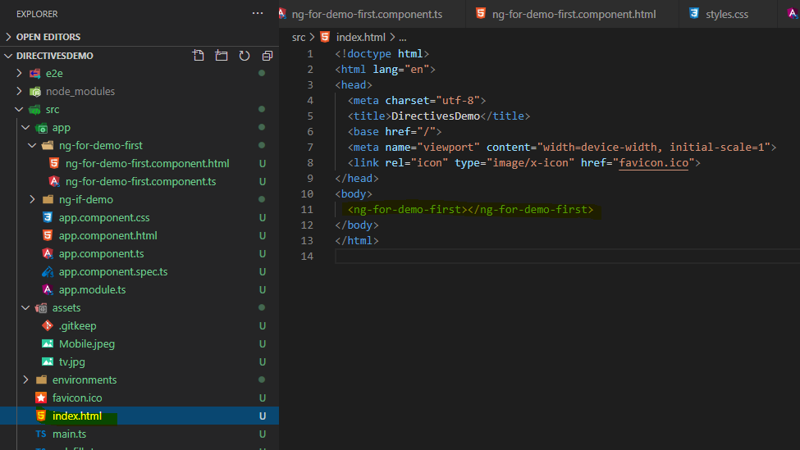

O/P : -

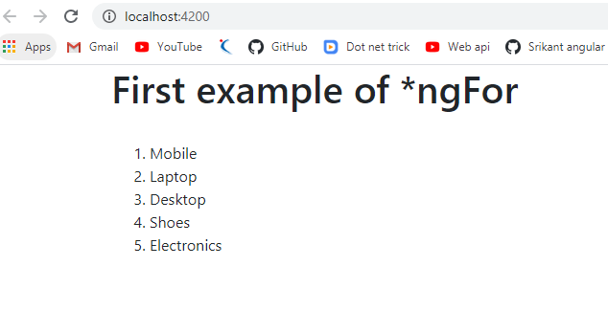

------------------------------------------------------------------------------------------------------------

Example 2:- ng g c ng-ForDemo-Second --skipTests -is

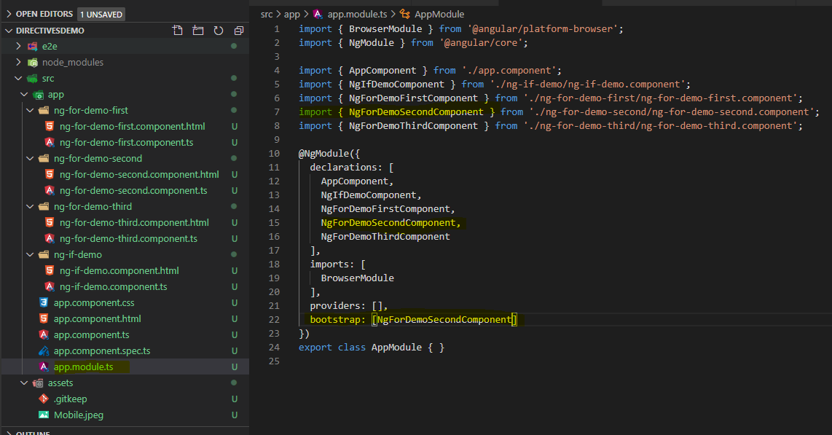

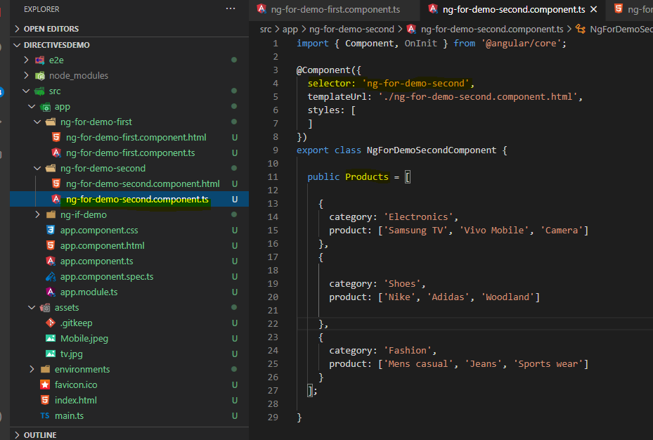

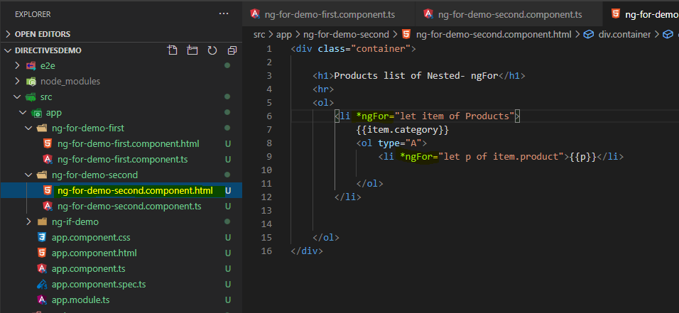

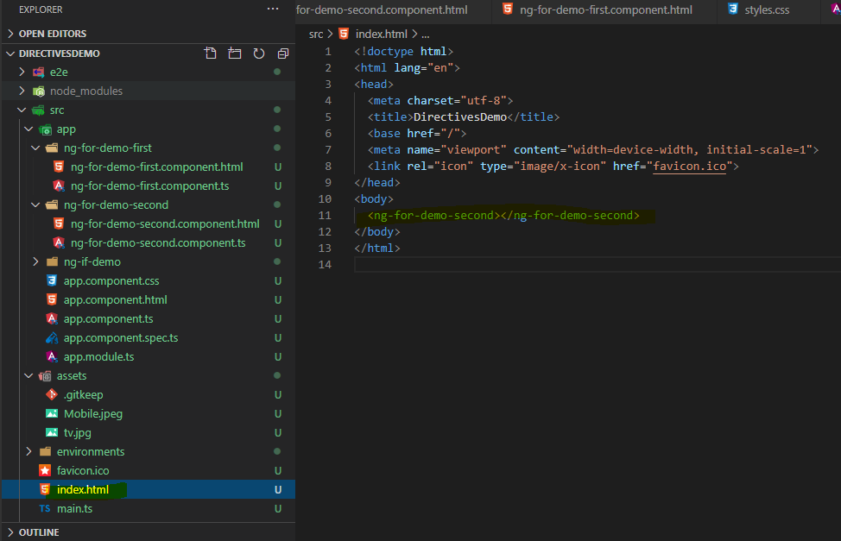

O/p:-

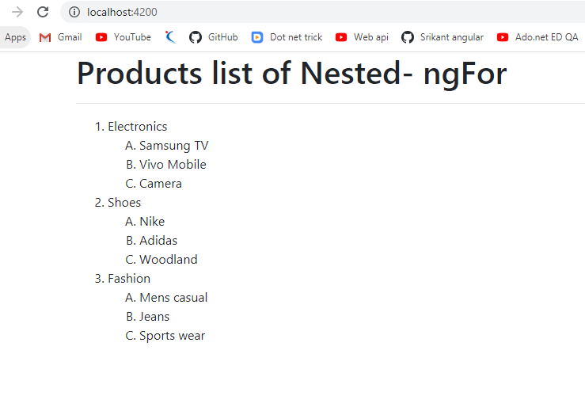

-----------------------------------------------------------------------------------------------------------------------

**Example** 3 : - ng g c ng-ForDemo-Third --skipTests -is

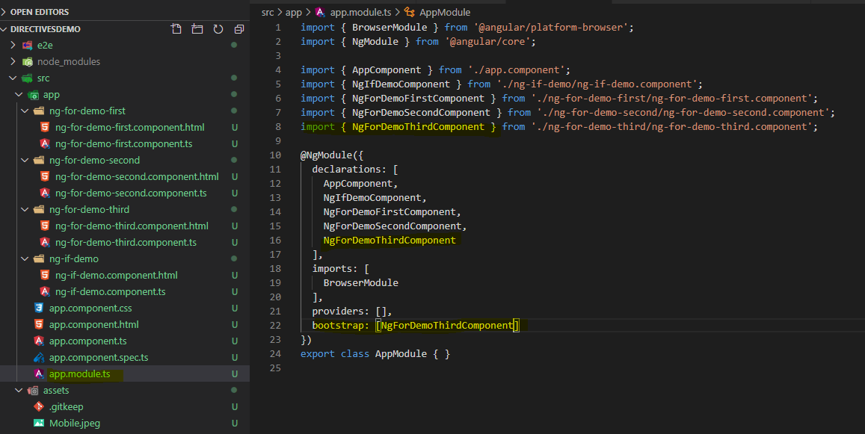

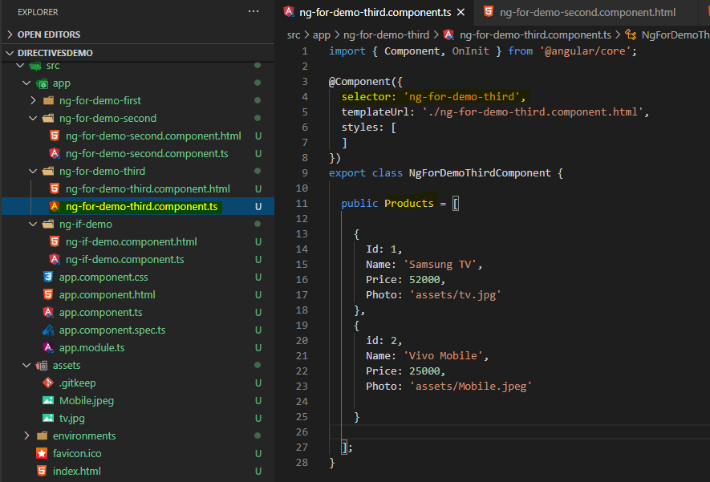

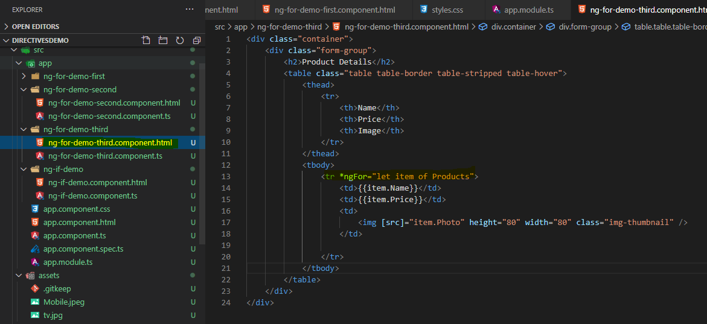

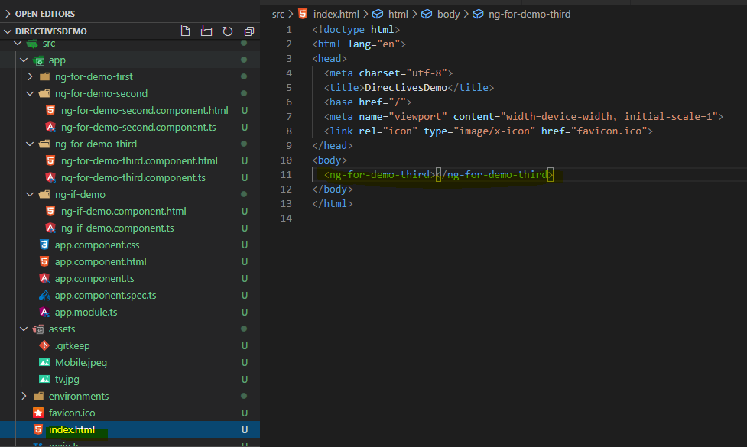

O/p: -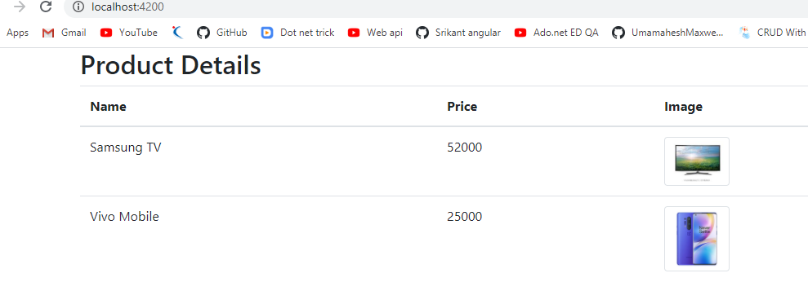

-----------------------------------------------------------------------------------------------------------------------------

**Example** 4 . ng g c ng-ForDemo-Fourth –-skipTests –is

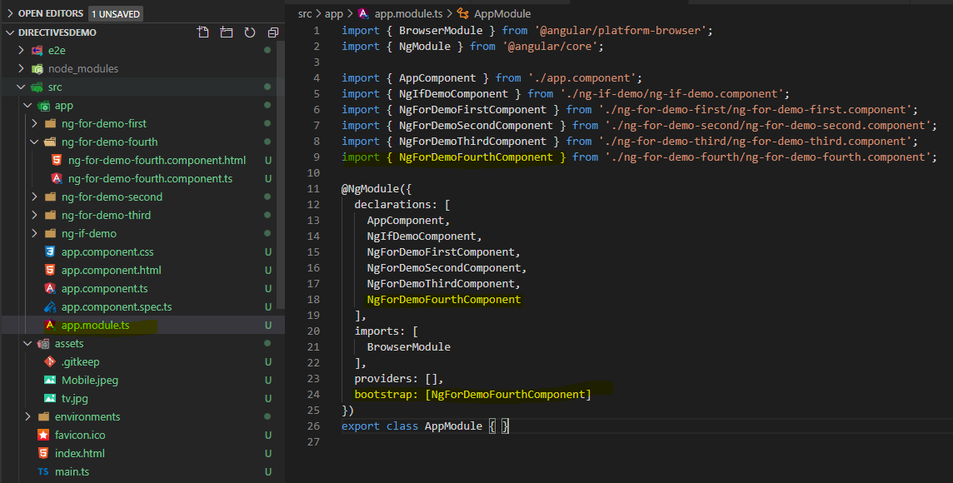

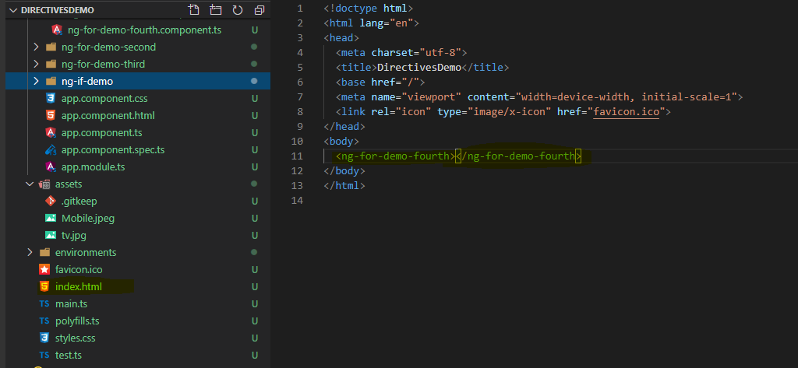 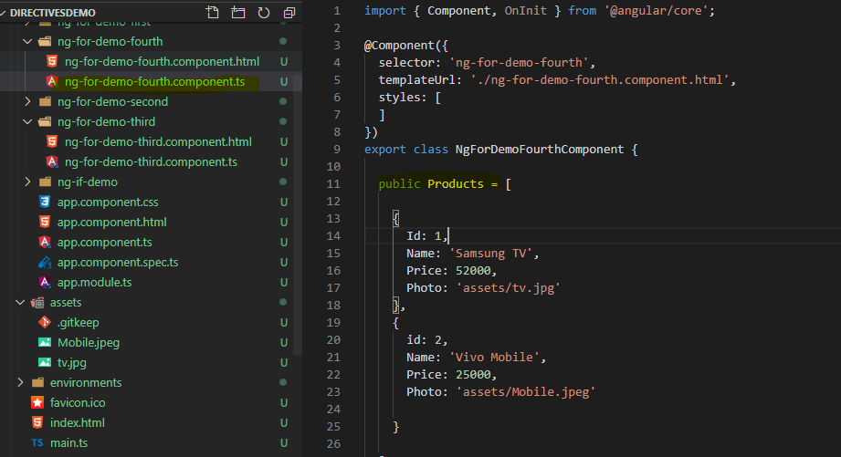

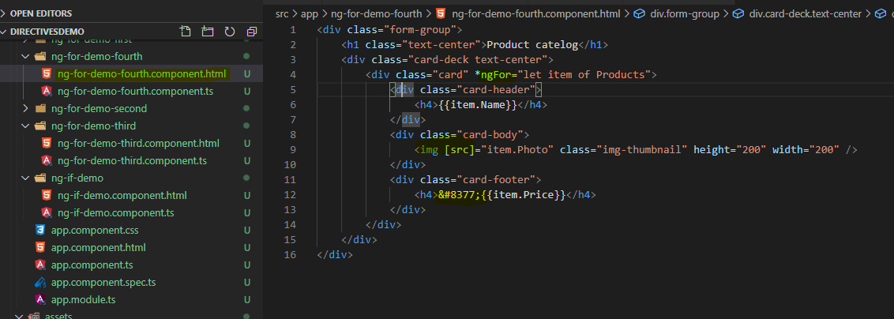

O/p: -

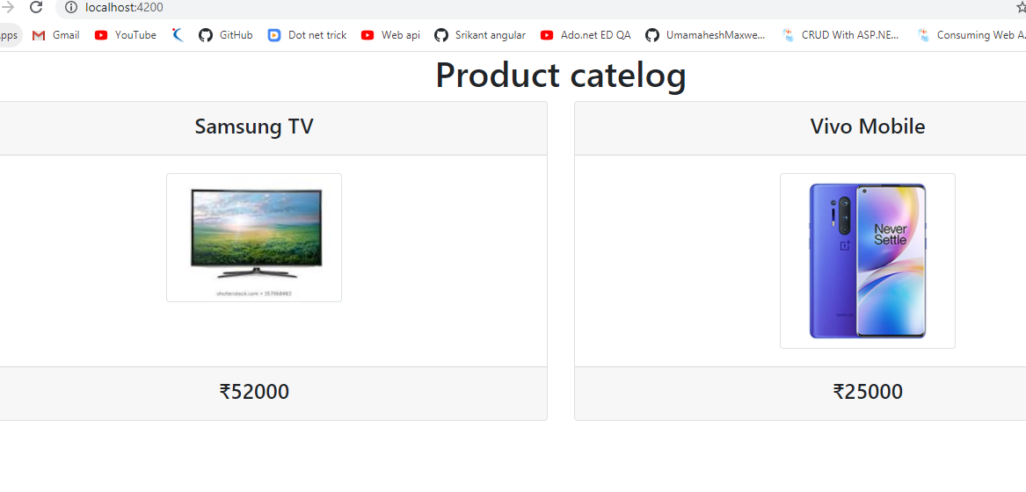

-------------------------------------------------------------------------------------------------------------------------------

3.**\*ngIf and else :**

* **If the condition is true one element is displayed else it will display another element.**
* **<tag *ngIf="condition;then template1;else template2"></tag>**
* **<ng-template #template1></ng-template>**
* **<ng-template #template2></ng-template>**
* **<ng-template> is a container, where we can have any tags inside that.**

**Create component –**

**ng g c ng-IfElse-Demo –skipTests –is**

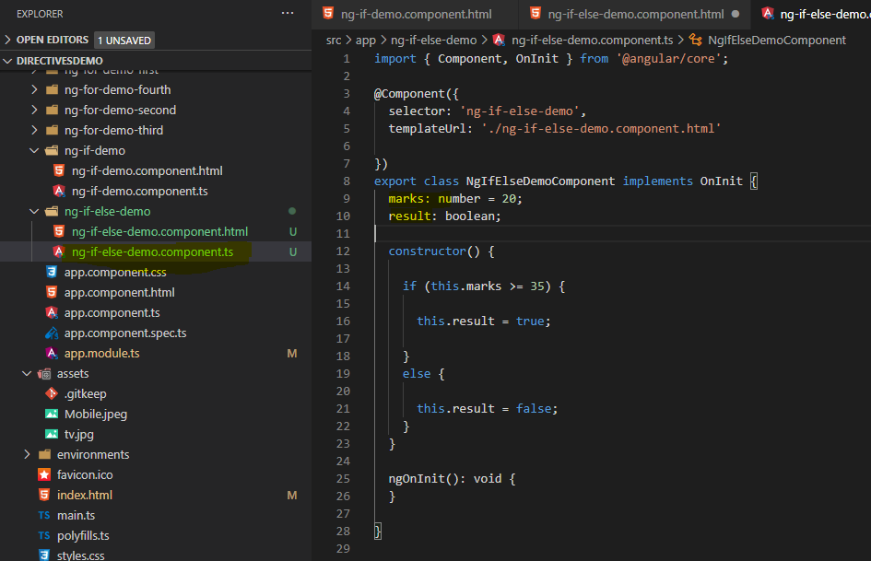

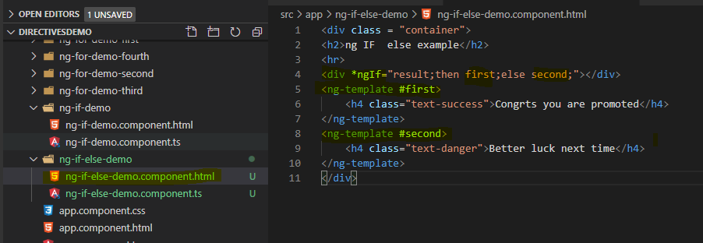

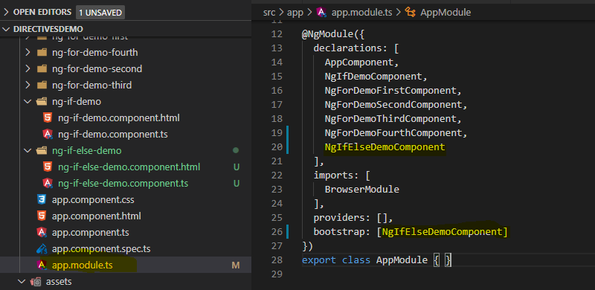

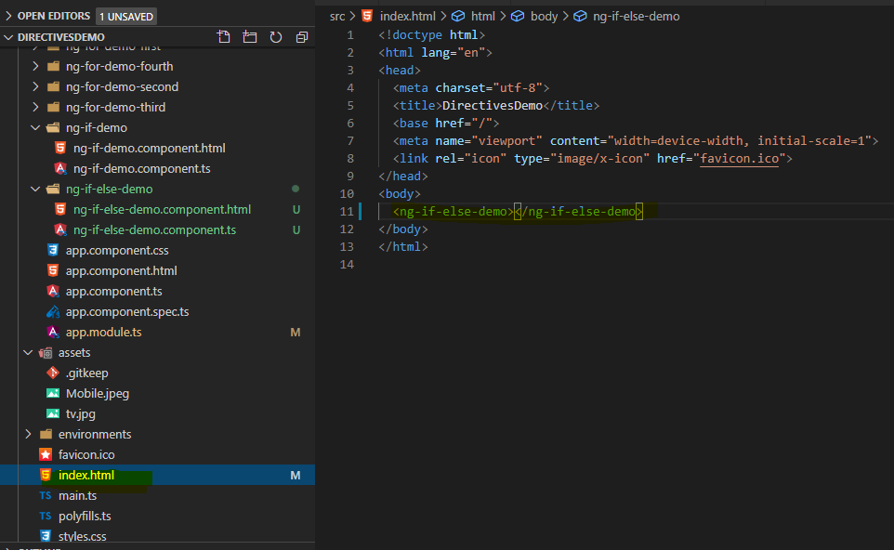

**O/p: - ng s -o**

**Case1: - IF number = 20 then**

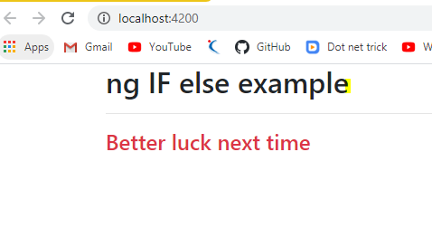

**Case 2:- If number =50 then**

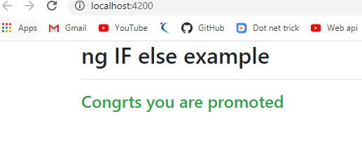

4.**NgSwitch : -**

* + It is similar to normal switch case, that ngSwitch will check the value of the variable, wether it matches with any of the case labels.
  + Once if it is matched then it will render that perticular HTML elememnts

**Syntax:**

* <tag [ngSwitch]="property">
* <tag *ngSwitchCase=" 'value' "></tag>
* <tag *ngSwitchCase=" 'value' "></tag>
* ......
* <tag*ngSwitchDefault></tag>
* </tag>

Example:- create component

Ng g c ngSwitch-Demo –skipTests –is

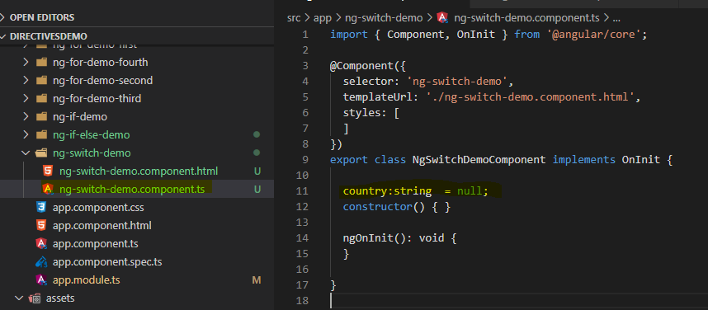

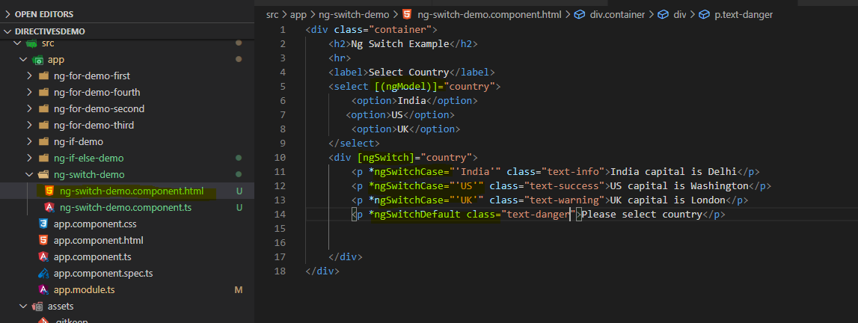

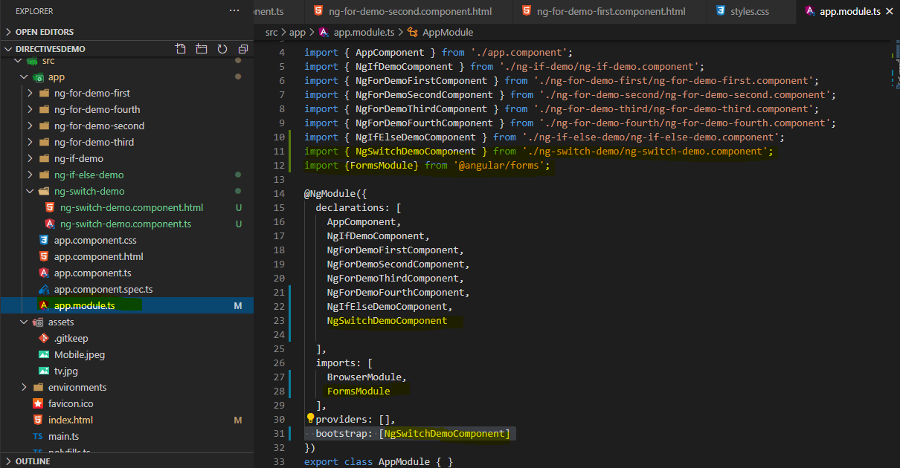

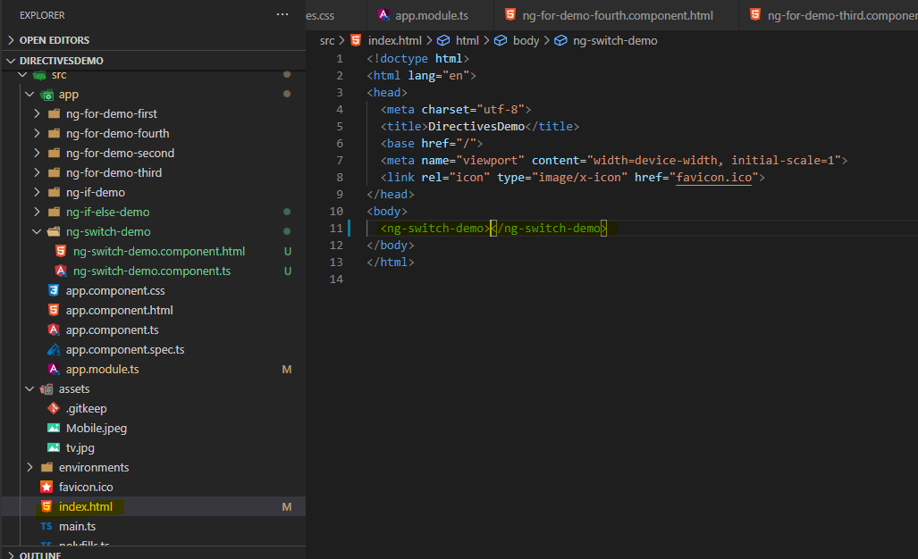

O/p:- ng s –o

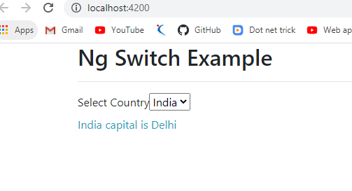

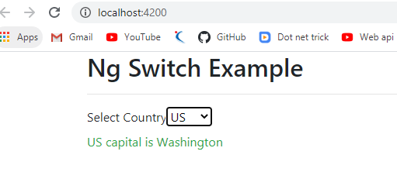

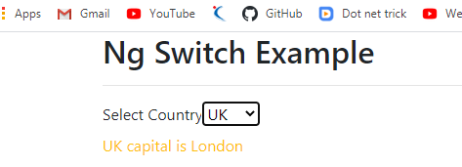

**2.Attribute Directive :-**

These directives will add/modify the behaviour of the elements like adding colours dynemically or removing colors and all the CSS properties if we want to add then will use this. Example [NgStyle] and [NgClass]

1. **Style**:

* is used to set the CSS property values dynemically at runtime..
* Once we cahnge the value then automatcally it changes the behaviour of html element as well.

**- <tag [style.cssProperty]="property"></tag>**

2.**ngClass:**

* It is used to apply the CSS classes dynemically.
* If we want to apply more than one CSS style for an HTML element we use this approch.

**- <tag [ngClass]="property"></tag>**

**Notes : Combined both example in 1 example.**

**Example:- ng g c styles-Demo**

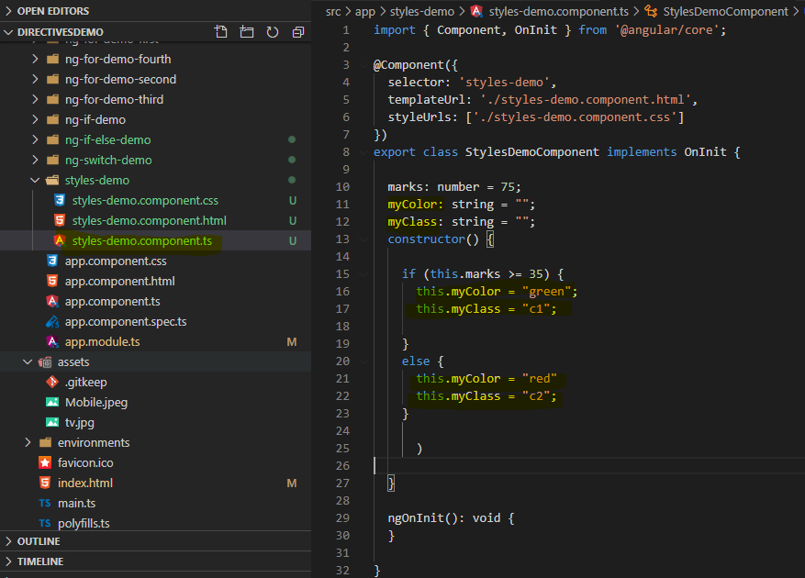

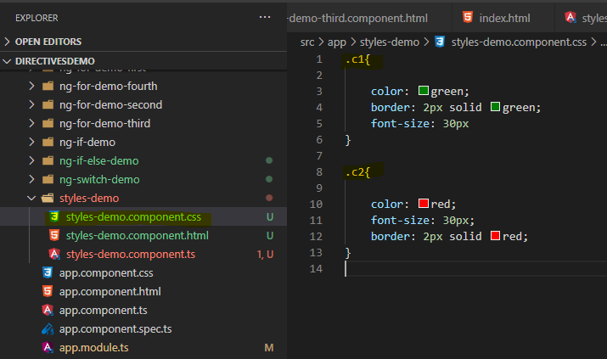

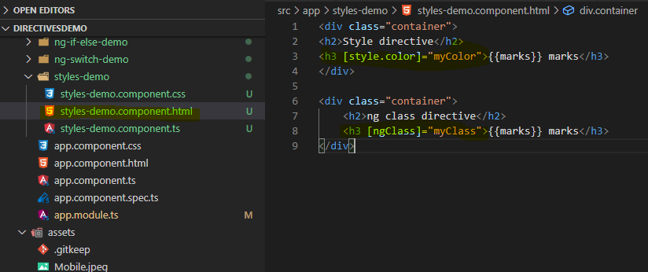 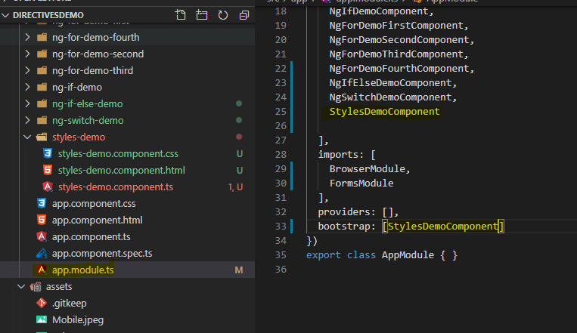

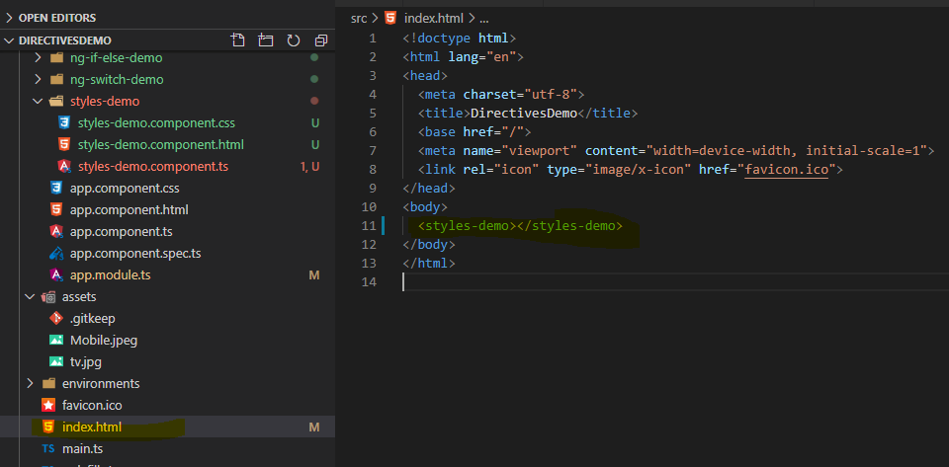

**o/p:-**

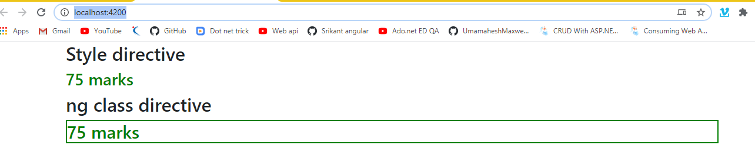

* **ngFor by using Object Array Add/Remove/Sort/Filter:**

**- When we are working with Arrays, In Javascirpt a class is avaible to perform manipulations like**

* + - 1. **- push() : It is used to add an element at the end of the array object**
      2. **- splice() : It is used for remove/add element**
      3. **- pop() : It is used to remove an element which is represented at end**
      4. **- filter() : Used to filter the data.**
      5. **- sort() : It can be used to perform sorting like ascending/descending**

1. **Insert and Delete record Example :-**

Ng g c EmpInsert-Delete –skipTests –is

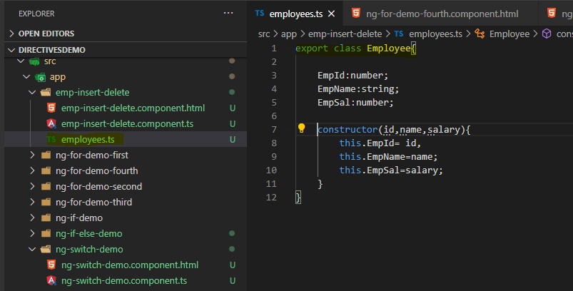

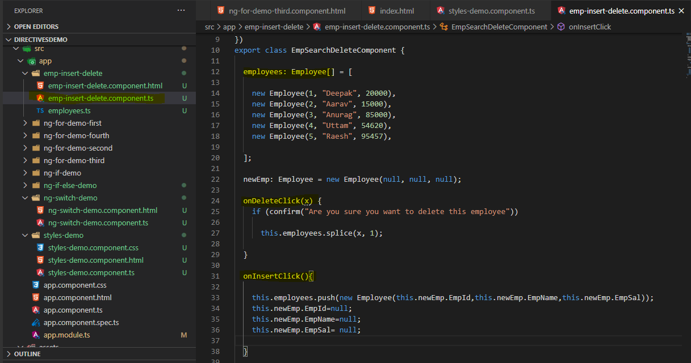

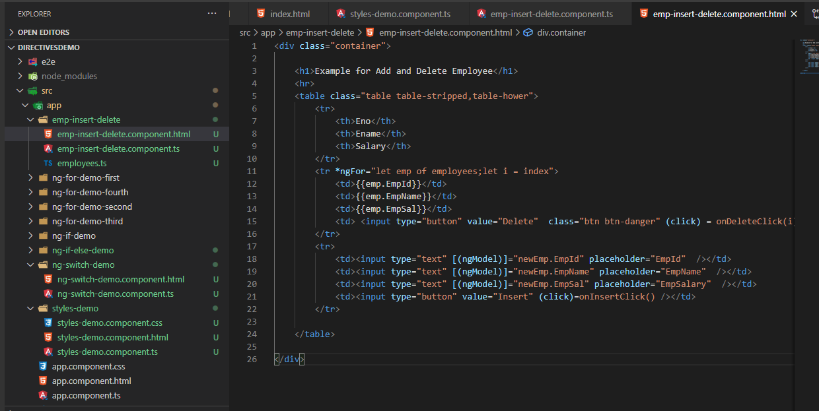

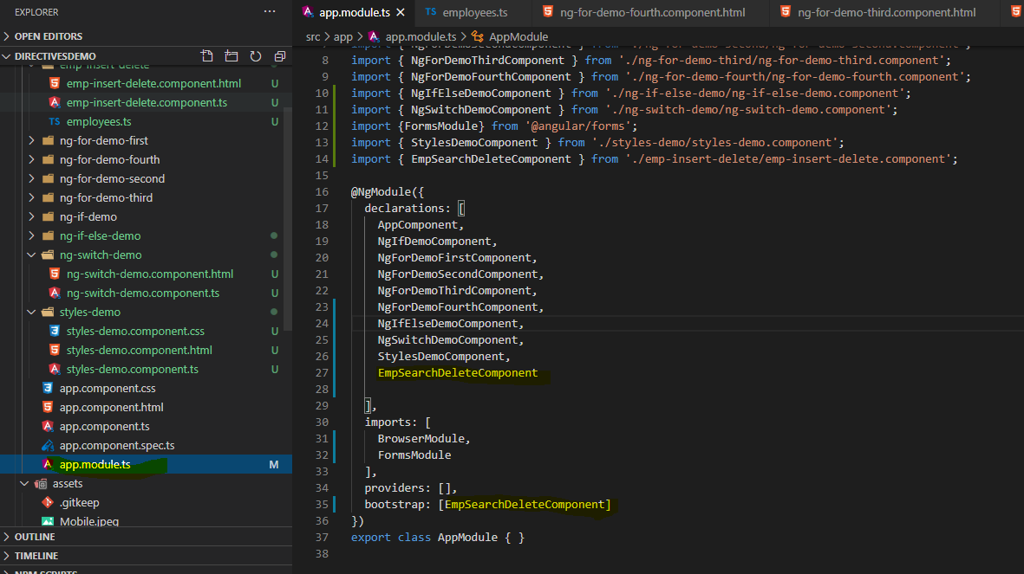

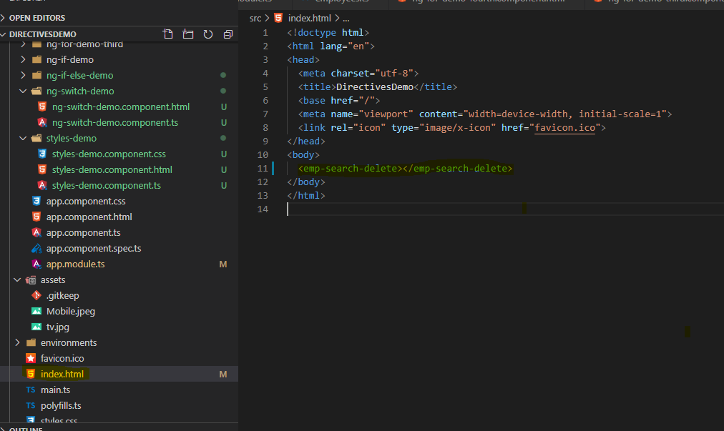

O/p:-

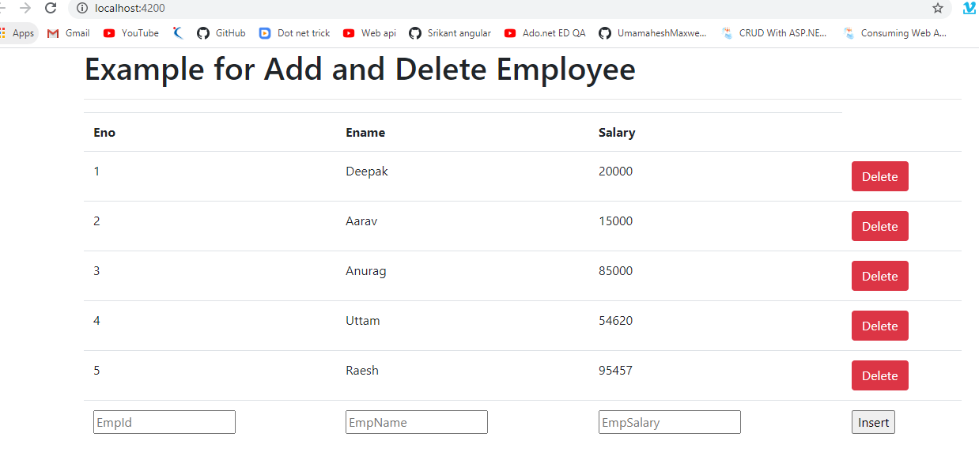

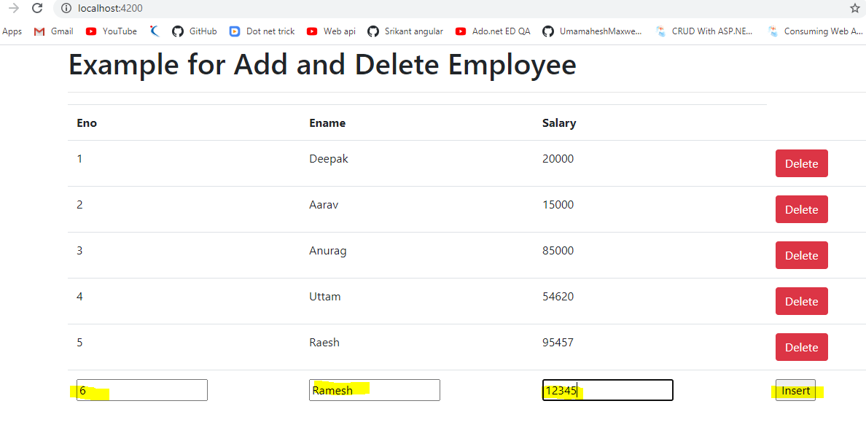

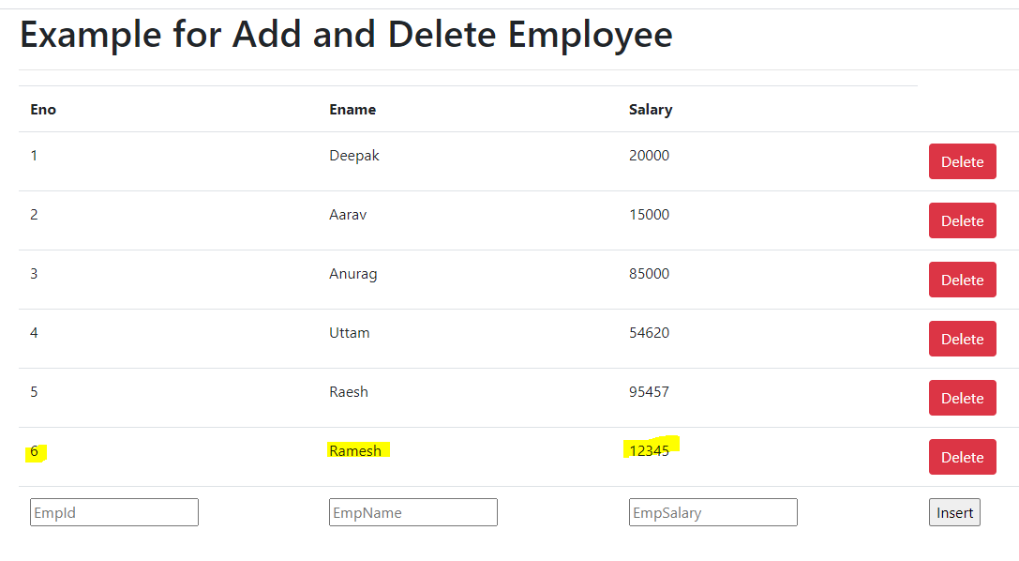

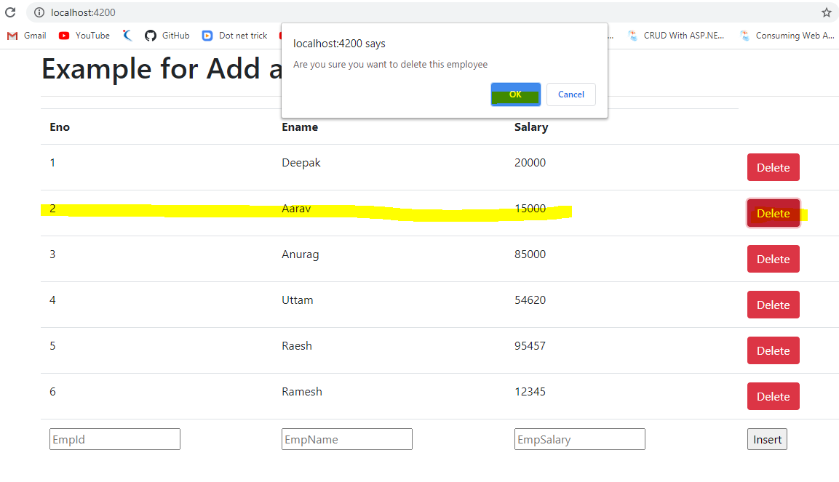

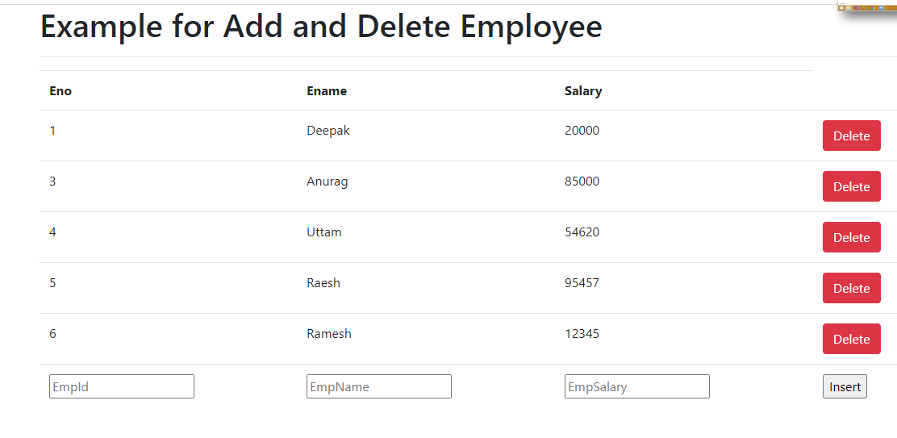

Record 2 is deleted.

**Sample Code:**

1. **Employee.ts:-**

export class Employee{

    EmpId:number;

    EmpName:string;

    EmpSal:number;

    constructor(id,name,salary){

        this.EmpId= id,

        this.EmpName=name;

        this.EmpSal=salary;

    }

}

2.emp-insert-delete.component.ts:-

import { Component, OnInit } from '@angular/core';

import { Employee } from './employees';

@Component({

  selector: 'emp-search-delete',

  templateUrl: './emp-insert-delete.component.html',

  styles: [

  ]

})

export class EmpSearchDeleteComponent {

  employees: Employee[] = [

    new Employee(1, "Deepak", 20000),

    new Employee(2, "Aarav", 15000),

    new Employee(3, "Anurag", 85000),

    new Employee(4, "Uttam", 54620),

    new Employee(5, "Raesh", 95457),

  ];

  newEmp: Employee = new Employee(null, null, null);

  onDeleteClick(x) {

    if (confirm("Are you sure you want to delete this employee"))

      this.employees.splice(x, 1);

  }

  onInsertClick(){

    this.employees.push(new Employee(this.newEmp.EmpId,this.newEmp.EmpName,this.newEmp.EmpSal));

    this.newEmp.EmpId=null;

    this.newEmp.EmpName=null;

    this.newEmp.EmpSal= null;

  }

}

1. Emp-insert-delete.component.html: -

<div class="container">

    <h1>Example for Add and Delete Employee</h1>

    <hr>

    <table class="table table-stripped,table-hower">

        <tr>

            <th>Eno</th>

            <th>Ename</th>

            <th>Salary</th>

        </tr>

        <tr *ngFor="let emp of employees;let i = index">

            <td>{{emp.EmpId}}</td>

            <td>{{emp.EmpName}}</td>

            <td>{{emp.EmpSal}}</td>

            <td> <input type="button" value="Delete"  class="btn btn-danger" (click) = onDeleteClick(i)/></td>

        </tr>

        <tr>

            <td><input type="text" [(ngModel)]="newEmp.EmpId" placeholder="EmpId"  /></td>

            <td><input type="text" [(ngModel)]="newEmp.EmpName" placeholder="EmpName"  /></td>

            <td><input type="text" [(ngModel)]="newEmp.EmpSal" placeholder="EmpSalary"  /></td>

            <td><input type="button" value="Insert" (click)=onInsertClick() /></td>

        </tr>

    </table>

</div>

******************************************************************

1. **Searching and Sorting of Employees:-**

Ng g c empSearch-Sort –skipTests –is



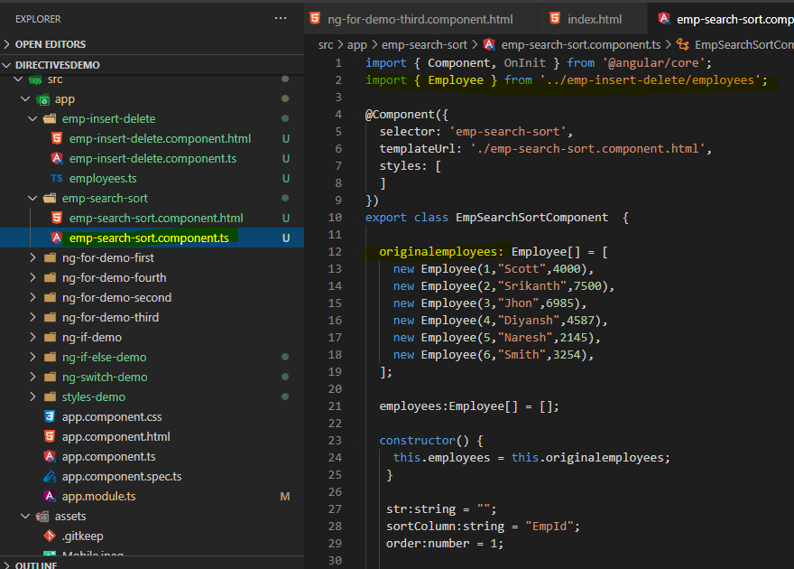

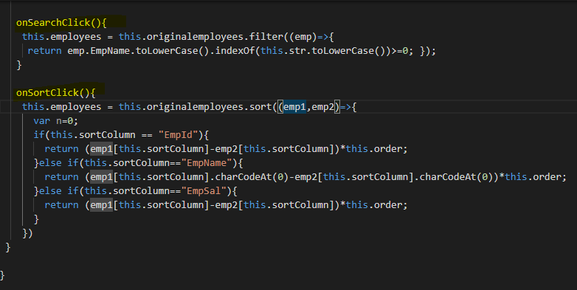

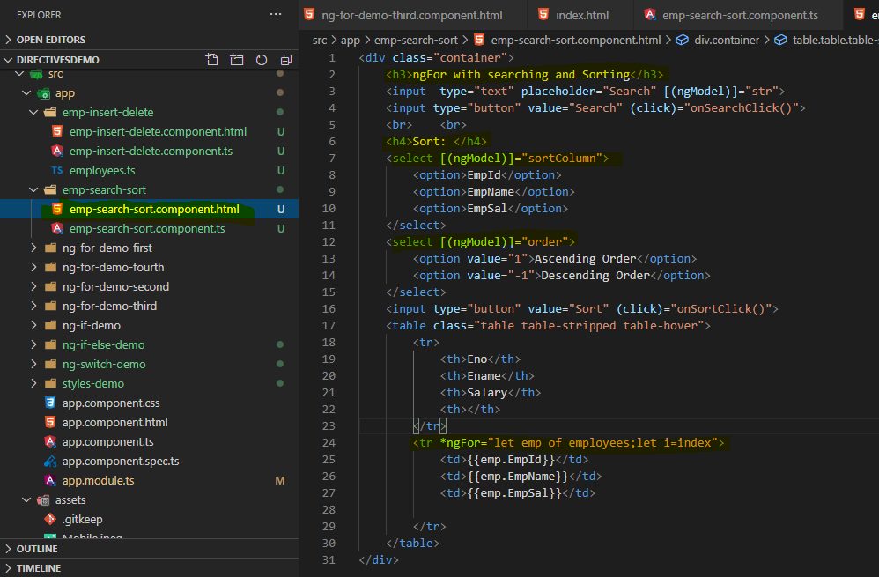

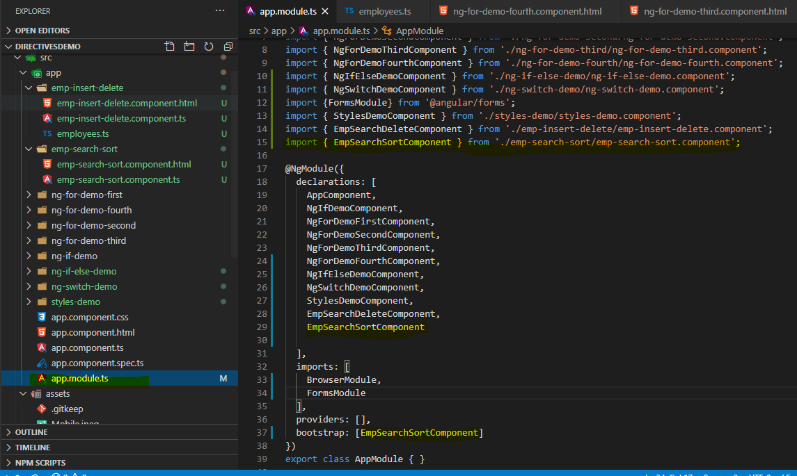

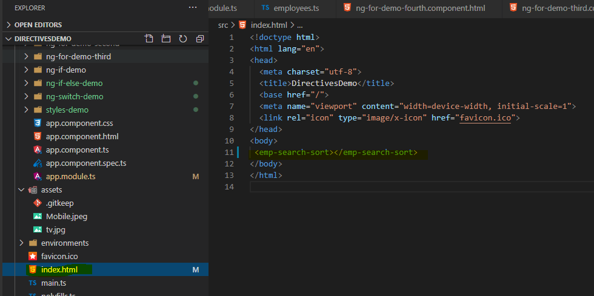

O/p-

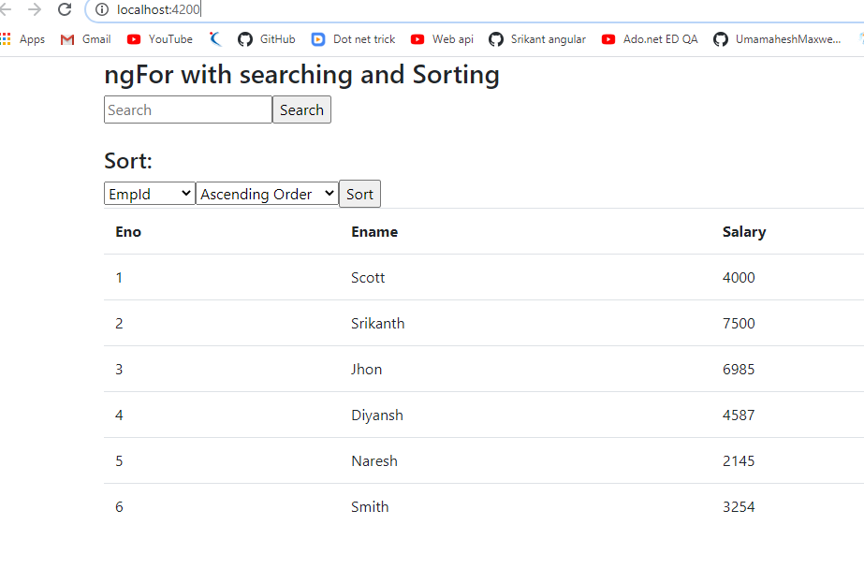

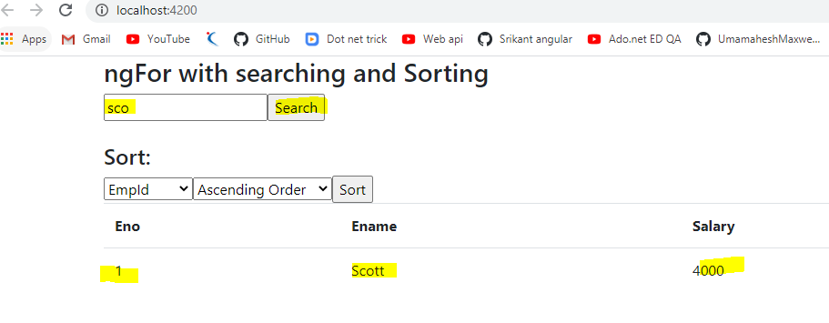

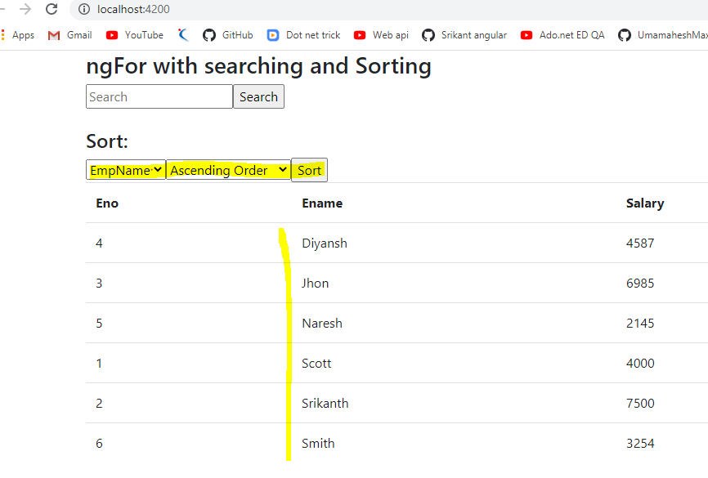

**Sample Code** :-

1. **Employee.ts:-**

export class Employee{

    EmpId:number;

    EmpName:string;

    EmpSal:number;

    constructor(id,name,salary){

        this.EmpId= id,

        this.EmpName=name;

        this.EmpSal=salary;

    }

}

1. **emp-search-sort.component.ts: -**

import { Component, OnInit } from '@angular/core';

import { Employee } from '../emp-insert-delete/employees';

@Component({

  selector: 'emp-search-sort',

  templateUrl: './emp-search-sort.component.html',

  styles: [

  ]

})

export class EmpSearchSortComponent  {

  originalemployees: Employee[] = [

    new Employee(1,"Scott",4000),

    new Employee(2,"Srikanth",7500),

    new Employee(3,"Jhon",6985),

    new Employee(4,"Diyansh",4587),

    new Employee(5,"Naresh",2145),

    new Employee(6,"Smith",3254),

  ];

  employees:Employee[] = [];

  constructor() {

    this.employees = this.originalemployees;

   }

   str:string = "";

   sortColumn:string = "EmpId";

   order:number = 1;

   onSearchClick(){

    this.employees = this.originalemployees.filter((emp)=>{

     return emp.EmpName.toLowerCase().indexOf(this.str.toLowerCase())>=0; });

   }

   onSortClick(){

    this.employees = this.originalemployees.sort((emp1,emp2)=>{

      var n=0;

      if(this.sortColumn == "EmpId"){

        return (emp1[this.sortColumn]-emp2[this.sortColumn])*this.order;

      }else if(this.sortColumn=="EmpName"){

        return (emp1[this.sortColumn].charCodeAt(0)-emp2[this.sortColumn].charCodeAt(0))*this.order;

      }else if(this.sortColumn=="EmpSal"){

        return (emp1[this.sortColumn]-emp2[this.sortColumn])*this.order;

      }

    })

 }

}

1. **Emp-search-sort.component.html :-**

<div class="container">

    <h3>ngFor with searching and Sorting</h3>

    <input  type="text" placeholder="Search" [(ngModel)]="str">

    <input type="button" value="Search" (click)="onSearchClick()">

    <br>    <br>

    <h4>Sort: </h4>

    <select [(ngModel)]="sortColumn">

        <option>EmpId</option>

        <option>EmpName</option>

        <option>EmpSal</option>

    </select>

    <select [(ngModel)]="order">

        <option value="1">Ascending Order</option>

        <option value="-1">Descending Order</option>

    </select>

    <input type="button" value="Sort" (click)="onSortClick()">

    <table class="table table-stripped table-hover">

        <tr>

            <th>Eno</th>

            <th>Ename</th>

            <th>Salary</th>

            <th></th>

        </tr>

        <tr *ngFor="let emp of employees;let i=index">

            <td>{{emp.EmpId}}</td>

            <td>{{emp.EmpName}}</td>

            <td>{{emp.EmpSal}}</td>

        </tr>

    </table>

</div>

**Component Communication in Angular**

- To share the data from one component to another component in Angular we have 4 options

1. @Input()
2. @Output()
3. @ViewChild()
4. @ViewChildren()
5. **@Input** -

This decorator is used to access the data from parent component to child components.

- At the time of creating properties in child component will define it by using @Input() decorator

@Input() Eno;

@Input() Ename;

@Input() Salary;

To work with @Input() and share the data follow the below steps

1. Create parent component with data.
2. Create the child component and define the properties using @Input()
3. Map the parent component data with child component properties
4. Initialize parent component.

**Create component:-**

* ng g c parent –skipTests –is
* ng g c child –skipTests -is

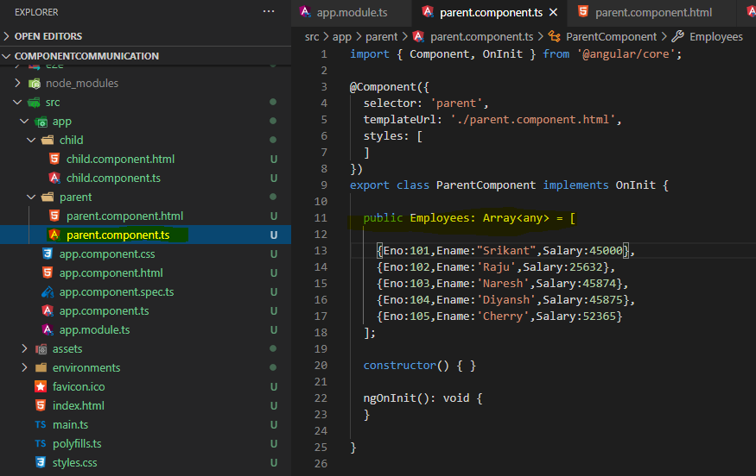

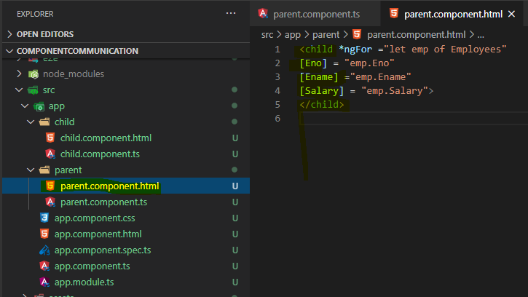

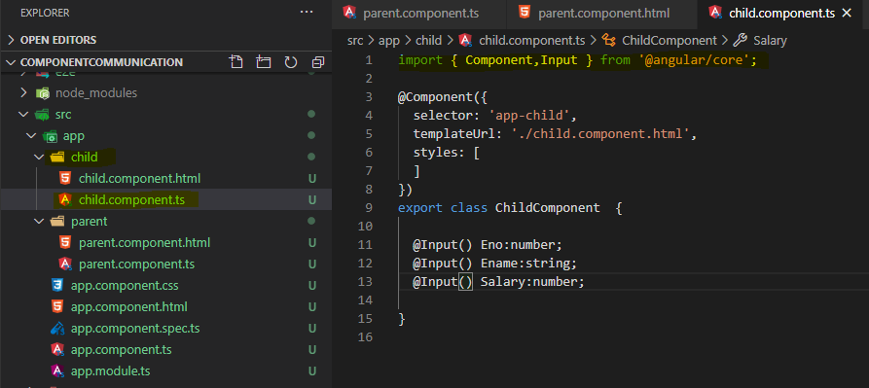

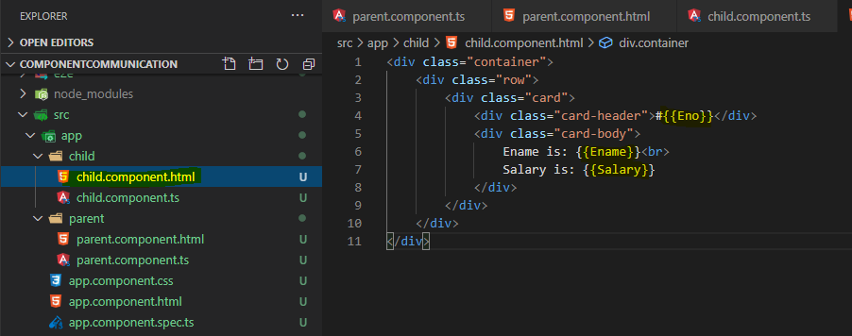

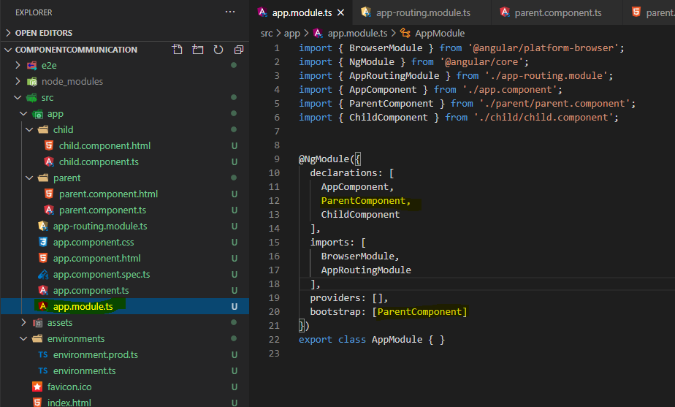

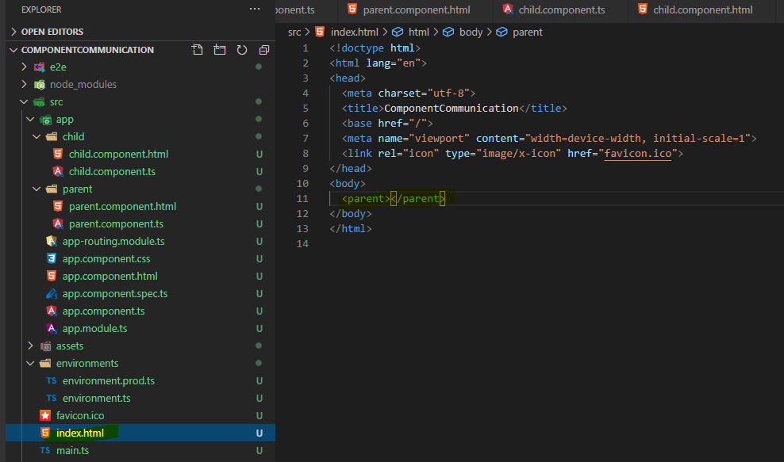

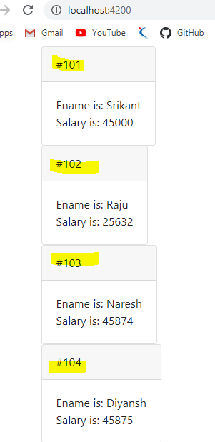

**Sample Code** : - 1. Parent.component.ts :-

import { Component, OnInit } from '@angular/core';

@Component({

  selector: 'parent',

  templateUrl: './parent.component.html',

  styles: [

  ]

})

export class ParentComponent implements OnInit {

  public Employees: Array<any> = [

    {Eno:101,Ename:"Srikant",Salary:45000},

    {Eno:102,Ename:'Raju',Salary:25632},

    {Eno:103,Ename:'Naresh',Salary:45874},

    {Eno:104,Ename:'Diyansh',Salary:45875},

    {Eno:105,Ename:'Cherry',Salary:52365}

  ];

  constructor() { }

  ngOnInit(): void {

  }

}

1. Parent.component.html:-

<child

[Eno] = "emp.Eno"

[Ename]="emp.Ename"

[Salary]="emp.Salary"

*ngFor="let emp of Employees"></child>

1. Child.component.ts:-

import { Component,Input } from '@angular/core';

@Component({

  selector: 'child',

  templateUrl: './child.component.html',

  styles: [

  ]

})

export class ChildComponent  {

  @Input() Eno:number;

  @Input() Ename:string;

  @Input() Salary:number;

}

1. Child.component.html:-

<div class="container">

    <div class="row">

        <div class="card">

            <div class="card-header">#{{Eno}}</div>

            <div class="card-body">

                Ename is: {{Ename}}<br>

                Salary is: {{Salary}}

            </div>

        </div>

    </div>

</div>

1. App.module.ts:-

import { BrowserModule } from '@angular/platform-browser';

import { NgModule } from '@angular/core';

import { AppComponent } from './app.component';

import { ParentComponent } from './parent/parent.component';

import { ChildComponent } from './child/child.component';

@NgModule({

  declarations: [

    AppComponent,

    ParentComponent,

    ChildComponent

  ],

  imports: [

    BrowserModule

  ],

  providers: [],

  bootstrap: [ParentComponent]

})

export class AppModule { }

1. Index.html:-

<body>

  <parent></parent>

</body>

1. **@Output:**

@Output(): This decorator is used to share the data from child component to parent component.

1. To work with this we will follow below steps like
2. Declare the @Output decorator in child component and define an event by using a class i.e. **EventEmitter** from @angular/core library.
3. Fire the event from child component template.by using any html control and any event we can use.
4. From the event handler bind the data to Output decorator property by using a method **emit**().
5. Map the event in the parent component.

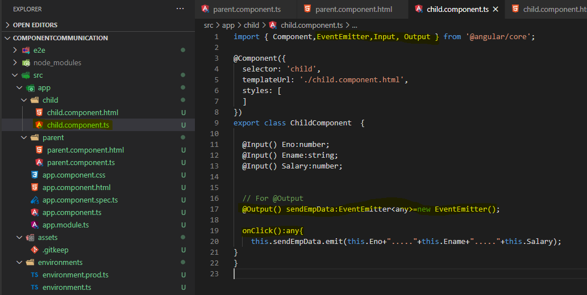

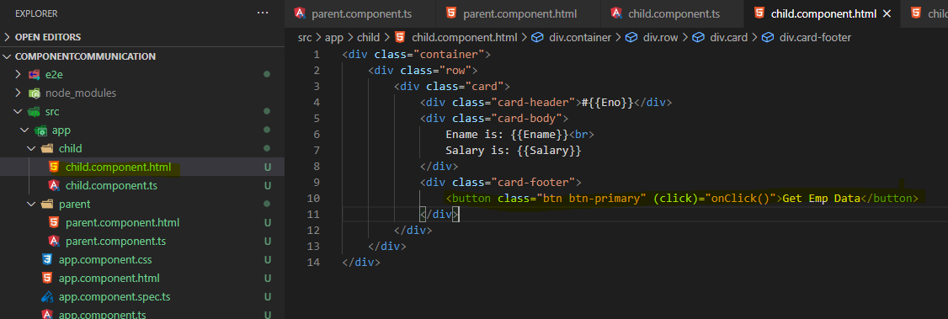

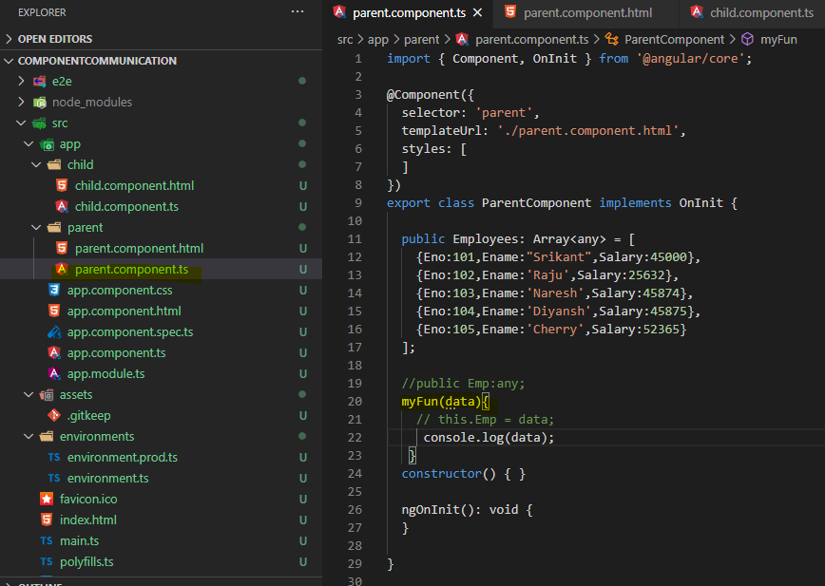

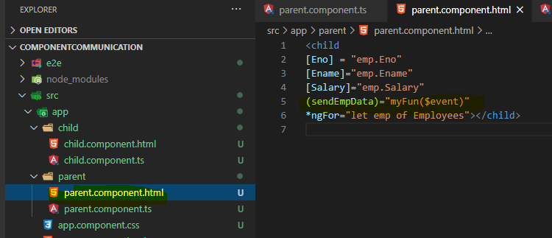



O/P:-

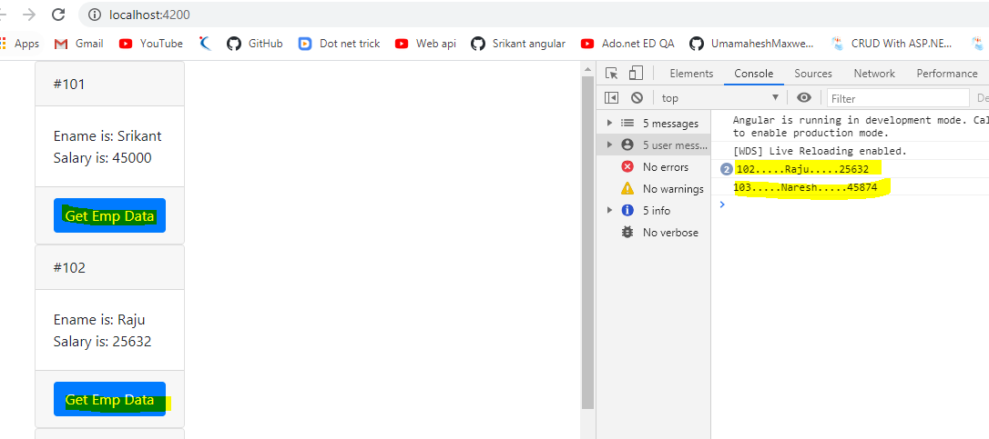

**Sample Code:-**

1. Child.component.ts:-

import { Component,EventEmitter,Input, Output } from '@angular/core';

@Component({

  selector: 'child',

  templateUrl: './child.component.html',

  styles: [

  ]

})

export class ChildComponent  {

  @Input() Eno:number;

  @Input() Ename:string;

  @Input() Salary:number;

  // For @Output

  @Output() sendEmpData:EventEmitter<any>=new EventEmitter();

  onClick():any{

    this.sendEmpData.emit(this.Eno+"....."+this.Ename+"....."+this.Salary);

}

}

1. Child.component.html:-

<div class="container">

    <div class="row">

        <div class="card">

            <div class="card-header">#{{Eno}}</div>

            <div class="card-body">

                Ename is: {{Ename}}<br>

                Salary is: {{Salary}}

            </div>

            <div class="card-footer">

                <button class="btn btn-primary" (click)="onClick()">Get Emp Data</button>

            </div>

        </div>

    </div>

</div>

1. Parent.component.ts:-

import { Component, OnInit } from '@angular/core';

@Component({

  selector: 'parent',

  templateUrl: './parent.component.html',

  styles: [

  ]

})

export class ParentComponent implements OnInit {

  public Employees: Array<any> = [

    {Eno:101,Ename:"Srikant",Salary:45000},

    {Eno:102,Ename:'Raju',Salary:25632},

    {Eno:103,Ename:'Naresh',Salary:45874},

    {Eno:104,Ename:'Diyansh',Salary:45875},

    {Eno:105,Ename:'Cherry',Salary:52365}

  ];

  //public Emp:any;

  myFun(data){

    // this.Emp = data;

     console.log(data);

   }

  constructor() { }

  ngOnInit(): void {

  }

}

1. Parent.component.html:-

<child

[Eno] = "emp.Eno"

[Ename]="emp.Ename"

[Salary]="emp.Salary"

(sendEmpData)="myFun($event)"

*ngFor="let emp of Employees"></child>

1. App.module.ts:-

import { BrowserModule } from '@angular/platform-browser';

import { NgModule } from '@angular/core';

import { AppComponent } from './app.component';

import { ParentComponent } from './parent/parent.component';

import { ChildComponent } from './child/child.component';

@NgModule({

  declarations: [

    AppComponent,

    ParentComponent,

    ChildComponent

  ],

  imports: [

    BrowserModule

  ],

  providers: [],

  bootstrap: [ParentComponent]

})

export class AppModule { }

1. Index.html:-

<body>

  <parent></parent>

</body>

1. **@ViewChild():-**

@ViewChild():

* + This decorator is used to share the data from two sibling components
  + It is used to manipulate the data from one component to another component as well.
  + To work with this we will create an Object of the component from the decorator like **@ViewChild(FirstComponent,{static:true}).**

**Create component**:-

* + - * ng g c first –skipTests –is
      * ng g c second –skipTests –i

1. first.component.ts:-

import { Component, OnInit } from '@angular/core';

@Component({

  selector: 'app-first',

  templateUrl: './first.component.html',

  styles: [

  ]

})

export class FirstComponent implements OnInit {

  Name:string;

  Location:string;

  constructor() {

    this.Name ="Srikanth";

    this.Location="Hyderabad";

  }

  ngOnInit(): void {

  }

}

1. first.component.html:-

<div class="container"></div>

<div class="text-primary">{{Name}} </div>

<div class="text-success">{{Location}} </div>

1. second.component.ts:-

import { Component, OnInit, ViewChild } from '@angular/core';

import { FirstComponent } from '../first/first.component';

@Component({

  selector: 'second',

  templateUrl: './second.component.html',

  styles: [

  ]

})

export class SecondComponent implements OnInit {

  @ViewChild(FirstComponent ,{ static: true })

  private _obj: FirstComponent;

  clickMe() {

    this._obj.Name = "Naresh";

    this._obj.Location = "Pune";

  }

  constructor() { }

  ngOnInit(): void {

  }

}

1. second.component.html: -

<div class="container">

<first></first>

<button class="btn btn-primary" (click)="clickMe()">Click Me</button>

</div>

1. app.modules.ts:-

import { BrowserModule } from '@angular/platform-browser';

import { NgModule } from '@angular/core';

import { AppComponent } from './app.component';

import { ParentComponent } from './parent/parent.component';

import { ChildComponent } from './child/child.component';

import { FirstComponent } from './first/first.component';

import { SecondComponent } from './second/second.component';

@NgModule({

  declarations: [

    AppComponent,

    ParentComponent,

    ChildComponent,

    FirstComponent,

    SecondComponent

  ],

  imports: [

    BrowserModule

  ],

  providers: [],

  bootstrap: [SecondComponent]

})

export class AppModule { }

1. Index.html:-

<body>

  <second></second>

</body>

O/p:-

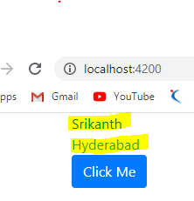

After clicking on button –

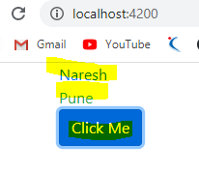

**Services in Anguler**

* A service is a reusable block of code/data which can be used across multiple components.
* Practically services can be used to implement methods for CRUD operations by using AJAX implmentation.
* A service in angular is a typescript class, which comes with a decorator "@Injectable()", This decorator is avilable in "@angular/core".
* This @Injectable() will contain a metadata property i.e. "providedIn:root", the purpose of this property is used to available the services globally.
* To create a service we use a CLI command like "ng g service <nameOfService>".

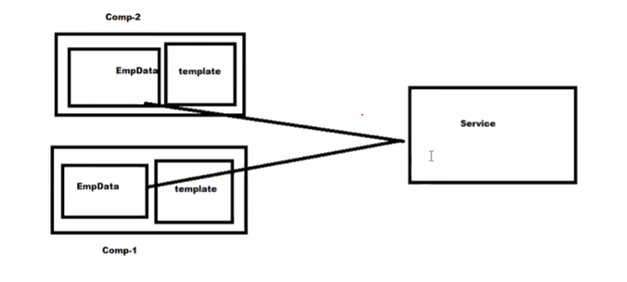

* **Create Application** > ng new ServiceDemo
* **Create Service** > ng g s employee
* **Create component** > ng g c employee

1. employee.service.ts :-

import { Injectable } from '@angular/core';

@Injectable({

  providedIn: 'root'

})

export class EmployeeService {

  getEmployee():any[]{

    return [

      {Eno:101,Ename:"Srikanth",Salary:12345},

      {Eno:102,Ename:"Sai",Salary:46461},

      {Eno:103,Ename:"Raju",Salary:78456},

      {Eno:104,Ename:"John",Salary:14687},

      {Eno:105,Ename:"Smith",Salary:85746}

    ]

  }

}

1. employee.component.ts:-

import { Component } from '@angular/core';

import { EmployeeService } from '../employee.service';

@Component({

  selector: 'employee',

  templateUrl: './employee.component.html',

  styles: [

  ]

})

export class EmployeeComponent  {

Employees:any[]

  constructor(private _serv : EmployeeService  ) {

    //this.Employees = this._serv.getEmployee();

   }

  ngOnInit(): void {

    this.Employees = this._serv.getEmployee();

  }

}

1. employee.component.html:-

<div class="container">

    <h1 class="text-center">Example with Angular Service</h1>

    <table class="table table-hover table-stripped">

        <tr>

            <td>Eno</td>

            <td>Ename</td>

            <td>Salary</td>

        </tr>

        <tr *ngFor="let emp of Employees">

            <td>{{emp.Eno}}</td>

            <td>{{emp.Ename}}</td>

            <td>{{emp.Salary}}</td>

        </tr>

    </table>

</div>

1. app.module.ts : -

import { BrowserModule } from '@angular/platform-browser';

import { NgModule } from '@angular/core';

import { AppComponent } from './app.component';

import { EmployeeComponent } from './employee/employee.component';

import {EmployeeService} from './employee.service';

@NgModule({

  declarations: [

    AppComponent,

    EmployeeComponent

  ],

  imports: [

    BrowserModule

  ],

  providers: [EmployeeService],

  bootstrap: [EmployeeComponent]

})

export class AppModule { }

1. Index.html:-

<body>

  <employee></employee>

</body>

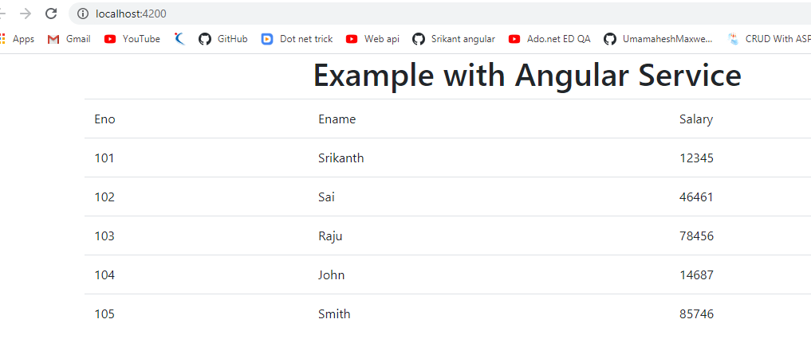

**RestAPI Service Calls:**

* To work with RestAPI, we use a class i.e. "HttpClient" class.
* This class is avaible under "@angular/common/http".
* It is continusly make a request to the server, what it gives it will observe., so that the return type of HttpClient is "Observable".
* This class is avaible in a library i.e. "rxjs", it stands for Reactive Extension Javascript.

Note: To work with Parallel execution of component we use "Observable" from 'rxjs-compat', becasue it is having a method i.e. "forkJoin([])".

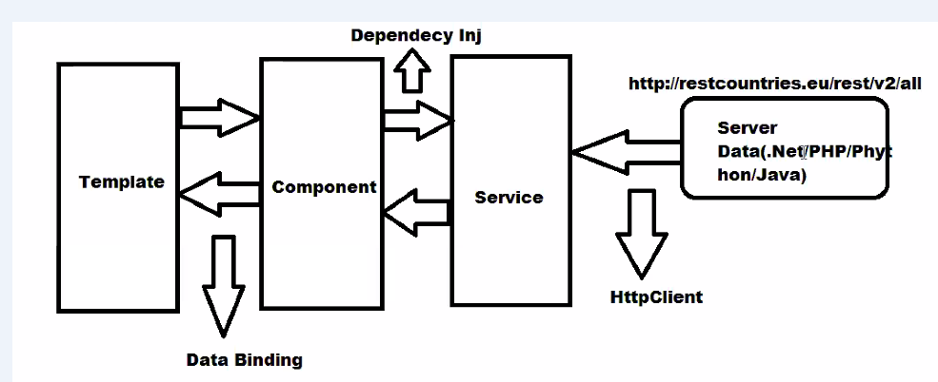

1. **Create application** => ng new CountriesServiceDemo
2. **Create service** => ng g s countries
3. **Create component** => ng g c countries
4. countries.service.ts :-

import { Injectable } from "@angular/core";

import { HttpClient } from "@angular/common/http";

import  {Observable } from 'rxjs';

@Injectable({

    providedIn: 'root'

})

export  class CountriesService  {

    //inject HttpClient class

    constructor(private http:HttpClient){

    }

    public getCountries():Observable<any>

    {

        return this.http.get('http://restcountries.eu/rest/v2/all');

    }

}

1. countries.component.ts ->

import { HttpErrorResponse } from '@angular/common/http';

import { ERROR_COMPONENT_TYPE } from '@angular/compiler';

import { Component, OnInit } from '@angular/core';

import { CountriesService } from '../countries.service';

@Component({

  selector: 'app-countries',

  templateUrl: './countries.component.html',

  styles: [

  ]

})

export class CountriesComponent implements OnInit {

  countries: Array<any>;

  constructor(private _serv: CountriesService) {

    this.countries = new Array<any>();

  }

  ngOnInit(): void {

    this._serv.getCountries().subscribe((responce) => {

      this.countries = responce;

    },

      (errRes: HttpErrorResponse) => {

        if (errRes.error instanceof Error) {

          console.log('client side error');

        }

        else {

          console.log('server side error');

        }

      })

  }

}

1. countries.component.html- >

<div class="container">

    <h1 class="text-center"> Countries Information </h1>

    <table class="table tabl-hover table-border table-stried">

        <tr>

            <th>Country Name</th>

            <th>Capital</th>

            <th>Flag</th>

        </tr>

        <tr *ngFor="let country of countries">

            <td>{{country.name}}</td>

            <td>{{country.capital}}</td>

            <td>

                <img [src]="country.flag" height="50px" width="100px"/>

            </td>

        </tr>

    </table>

</div>

1. App.module.ts:-

import { BrowserModule } from '@angular/platform-browser';

import { NgModule } from '@angular/core';

import { AppComponent } from './app.component';

import { CountriesComponent } from './countries/countries.component';

import { CountriesService } from './countries.service';

import { HttpClientModule } from '@angular/common/http';

@NgModule({

  declarations: [

    AppComponent,

    CountriesComponent

  ],

  imports: [

    BrowserModule,

    HttpClientModule

  ],

  providers: [CountriesService],

  bootstrap: [CountriesComponent]

})

export class AppModule { }

1. Index.html:-

<body>

  <app-countries></app-countries>

</body>

O/P – ng s –o

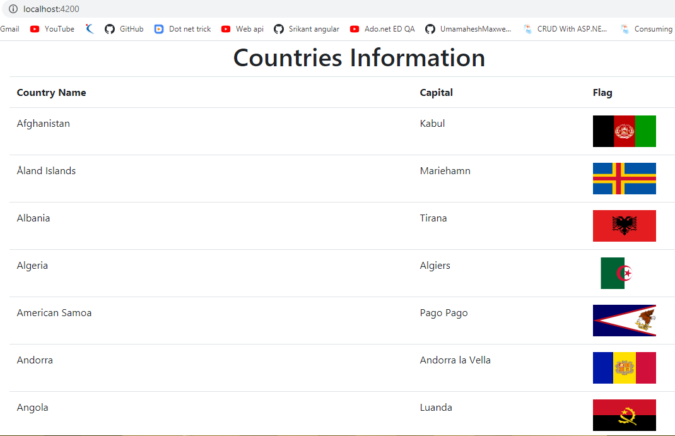

**Pagination in above application**

> npm install --save ngx-pagination

> import {NgxPaginationModule} from 'ngx-pagination';

1. countries.service.ts :-

import { Injectable } from "@angular/core";

import { HttpClient } from "@angular/common/http";

import  {Observable } from 'rxjs';

@Injectable({

    providedIn: 'root'

})

export  class CountriesService  {

    //inject HttpClient class

    constructor(private http:HttpClient){

    }

    public getCountries():Observable<any>

    {

        return this.http.get('http://restcountries.eu/rest/v2/all');

    }

}

1. countries.component.ts ->

import { HttpErrorResponse } from '@angular/common/http';

import { Component, OnInit } from '@angular/core';

import { CountriesService } from '../countries.service';

@Component({

  selector: 'app-countries',

  templateUrl: './countries.component.html',

  styles: [

  ]

})

export class CountriesComponent implements OnInit {

  countries: Array<any>;

  // for pagination

  totalRecords:number;

  page:number=1;

  constructor(private _serv: CountriesService) {

    this.countries = new Array<any>();

  }

  ngOnInit(): void {

    this._serv.getCountries().subscribe((responce) => {

      this.countries = responce;

      //for pagination

     this.totalRecords= this.countries.length;

    },

      (errRes: HttpErrorResponse) => {

        if (errRes.error instanceof Error) {

          console.log('client side error');

        }

        else {

          console.log('server side error');

        }

      })

  }

}

1. countries.component.html- >

<div class="container">

    <h1 class="text-center">Countries Information</h1>

    <table class="table table-hover table-borderd table-stripped">

        <tr>

            <th>Country Name</th>

            <th>Capital</th>

            <th>Flag</th>

        </tr>

        <tr *ngFor="let country of countries | paginate:{id:'list',itemsPerPage:10,currentPage:page,totalItems:totalRecords}">

            <td>{{country.name}}</td>

            <td>{{country.capital}}</td>

            <td>

                <img [src]="country.flag" width="100px" height="50px"/>

            </td>

        </tr>

    </table>

    <pagination-controls  id="list"

                      maxSize="10"

                      directionLinks="true"

                      responsive="true"

                      previousLabel="Previous"

                      nextLabel="Next"

                      (pageChange) = "page = $event"

                      >

</pagination-controls>

</div>

1. App.module.ts:-

import { BrowserModule } from '@angular/platform-browser';

import { NgModule } from '@angular/core';

import { AppRoutingModule } from './app-routing.module';

import { AppComponent } from './app.component';

import { CountriesComponent } from './countries/countries.component';

import { CountriesService } from './countries.service';

import { HttpClientModule } from '@angular/common/http';

import {NgxPaginationModule} from 'ngx-pagination';

@NgModule({

  declarations: [

    AppComponent,

    CountriesComponent

  ],

  imports: [

    BrowserModule,

    AppRoutingModule,

    HttpClientModule,

    NgxPaginationModule

  ],

  providers: [CountriesService],

  bootstrap: [CountriesComponent]

})

export class AppModule { }

1. .html:-

<body>

  <app-countries></app-countries>

</body>

O/P – ng s –o

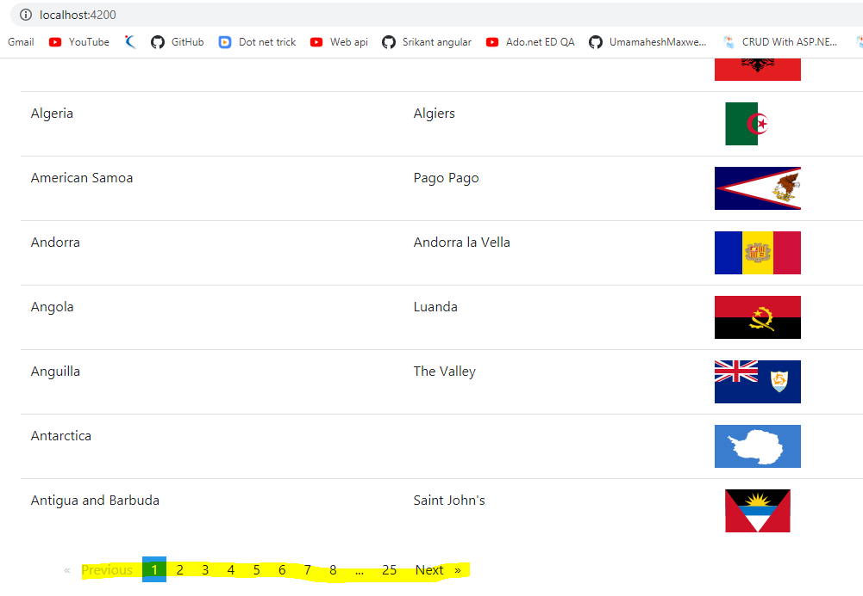

**Series and Parallel Service execution in Angular**

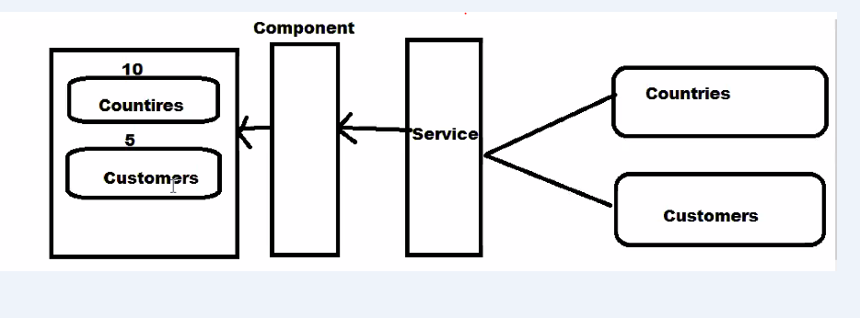

**Note : -**

1. **Suppose we have 2 services, countries and customer and if we want to load both the services one after another then we use series execution.**
2. **If we want to execute services parallel then we use parallel execution.**

Note: To work with Parallel execution of component we use "Observable" from 'rxjs-compat', becasue it is having a method i.e. "forkJoin([])".

To use forkJoin() you have to install package in our aaplication.

> npm add rxjs-compat

1. **Series execution:-**

**Create service >**

**ng g s countries**

**ng g s customer**

**Create component ->**

**ng g c series**

1. **countries.service.ts :-**

import { Injectable } from '@angular/core';

import {HttpClient} from '@angular/common/http';

import {Observable} from 'rxjs';

@Injectable({

  providedIn: 'root'

})

export class CountriesService {

  constructor(private _http:HttpClient) { }

  getCountries():Observable<any>{

    return this._http.get('http://restcountries.eu/rest/v2/all');

  }

}

1. **customers.service.ts:-**

import { Injectable } from '@angular/core';

import  {HttpClient} from '@angular/common/http';

import {Observable} from 'rxjs';

@Injectable({

  providedIn: 'root'

})

export class CustomersService {

  constructor( private _http:HttpClient) { }

  getCustomers():Observable<any>{

    return this._http.get('https://www.w3schools.com/angular/customers.php');

  }

}

1. **series.component.ts:-**

import { Component, OnInit } from '@angular/core';

import { CountriesService } from '../countries.service';

import { CustomersService } from '../customers.service';

@Component({

  selector: 'series',

  templateUrl: './series.component.html',

  styles: [

  ]

})

export class SeriesComponent implements OnInit {

  countries: any;

  customers: any;

  constructor(private _serv1: CustomersService, private _serv2: CountriesService) { }

  ngOnInit(): void {

    this._serv1.getCustomers().subscribe((posRes) => {

      this.customers = posRes;

      this._serv2.getCountries().subscribe((posRes) => {

        this.countries = posRes

      },

        (errRes) => {

          console.log('Error occoured while processing the request');

        })

    }, (errRes) => {

      console.log('Error occoured while processing the request');

    })

  }

}

1. **series.component.html:-**

<div>

<h5 style="color:red">{{customers | json }}</h5>

<br><hr><br>

<h5 style="color: green;">{{countries | json}}</h5>

</div>

**5.App.module.ts:-**

import { BrowserModule } from '@angular/platform-browser';

import { NgModule } from '@angular/core';

import { AppComponent } from './app.component';

import { SeriesComponent } from './series/series.component';

import { CountriesService } from './countries.service';

import { CustomersService } from './customers.service';

import { HttpClientModule } from '@angular/common/http';

@NgModule({

  declarations: [

    AppComponent,

    SeriesComponent

  ],

  imports: [

    BrowserModule,

    HttpClientModule

  ],

  providers: [CountriesService,CustomersService],

  bootstrap: [SeriesComponent]

})

export class AppModule { }

1. **Index.html :-**
2. <body>
3. <series></series>
4. </body>

**o/p: ng s –o**

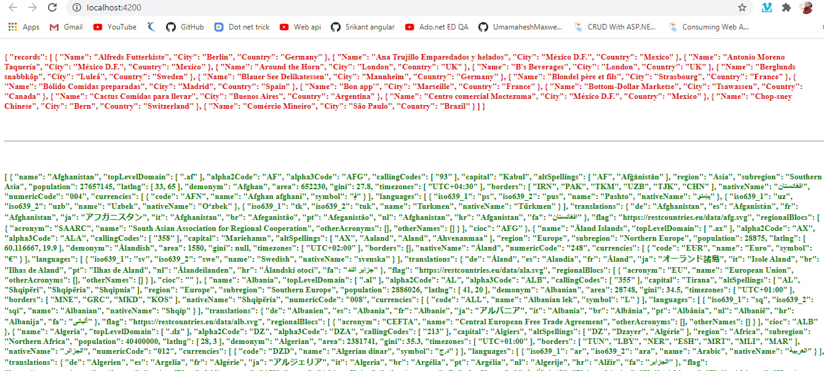

**Red color data will display first then green color dta will execute.**

1. **Parallel execution:-**

**If we want to execute services parallel then we use parallel execution.**

Note: To work with Parallel execution of component we use "Observable" from 'rxjs-compat', becasue it is having a method i.e. "forkJoin([])".

To use forkJoin() you have to install package in our aaplication.

**Install package >**

**> npm add rxjs-compat**

**Create service >**

**ng g s countries**

**ng g s customer**

**Create component ->**

**ng g c parallel**

1. **countries.service.ts :-**

import { Injectable } from '@angular/core';

import {HttpClient} from '@angular/common/http';

import {Observable} from 'rxjs';

@Injectable({

  providedIn: 'root'

})

export class CountriesService {

  constructor(private _http:HttpClient) { }

  getCountries():Observable<any>{

    return this._http.get('http://restcountries.eu/rest/v2/all');

  }

}

1. **customers.service.ts:-**

import { Injectable } from '@angular/core';

import  {HttpClient} from '@angular/common/http';

import {Observable} from 'rxjs';

@Injectable({

  providedIn: 'root'

})

export class CustomersService {

  constructor( private _http:HttpClient) { }

  getCustomers():Observable<any>{

    return this._http.get('https://www.w3schools.com/angular/customers.php');

  }

}

1. **parallel.component.ts:-**

import { Component, OnInit } from '@angular/core';

import { Observable } from 'rxjs-compat';

import { CountriesService } from '../countries.service';

import { CustomersService } from '../customers.service';

@Component({

  selector: 'parallel',

  templateUrl: './parallel.component.html',

  styles: [

  ]

})

export class ParallelComponent implements OnInit {

  countries:any;

  customers:any;

  constructor(private _serv1: CustomersService, private _serv2: CountriesService) { }

  ngOnInit(): void {

    Observable.forkJoin([

      this._serv1.getCustomers(),

      this._serv2.getCountries()

    ]).subscribe((posRes) => {

      this.customers= posRes[0];

      this.countries = posRes[1];

    }, (errRss) => {

      console.log('error occoured')

    })

  }

}

1. **parallel.component.html:-**
2. <div>
3. <h5 style="color:red">{{customers | json }}</h5>
4. <br>
5. <hr><br>
6. <h5 style="color: green;">{{countries | json}}</h5>
7. </div>
8. **app.module.ts:-**

import { BrowserModule } from '@angular/platform-browser';

import { NgModule } from '@angular/core';

import { AppComponent } from './app.component';

import { SeriesComponent } from './series/series.component';

import { CountriesService } from './countries.service';

import { CustomersService } from './customers.service';

import { HttpClientModule } from '@angular/common/http';

import { ParallelComponent } from './parallel/parallel.component';

@NgModule({

  declarations: [

    AppComponent,

    SeriesComponent,

    ParallelComponent

  ],

  imports: [

    BrowserModule,

    HttpClientModule

  ],

  providers: [CountriesService,CustomersService],

  bootstrap: [ParallelComponent]

})

export class AppModule { }

1. **index.html:-**

<body>

  <parallel></parallel>

</body>

**O/p:- Both customer and countries will be display parallel.**

